CARL-WSN: Context-Aware Reinforcement Learning for Hybrid Routing in Heterogeneous IoT-Driven Wireless Sensor Networks
Aymen Jaber Salman
Atheel Nowfal Alkhayyat
Ruslan Saad Abdulrahman
Department of Computer Engineering, Al-Nahrain University, Baghdad, Iraq
Abstract
Wireless Sensor Networks (WSNs) in IoT-driven smart cities carry heterogeneous traffic with conflicting quality-of-service demands, yet no existing routing protocol — including reinforcement learning (RL) approaches such as RLCR and FQ-UCR, which apply Q-Learning within a single fixed paradigm — learns to select between fundamentally different routing paradigms per packet, leaving that choice urgency-blind. This paper introduces CARL-WSN, a Context-Aware RL protocol that dynamically selects the routing paradigm — proactive, reactive, or hybrid — per packet via tabular Q-Learning over a context vector of urgency, residual energy, and link stability. A hard safety constraint forces emergency traffic onto proactive routing regardless of policy, guaranteeing sub-100 ms delivery. Evaluated in MATLAB against eight baselines — including RPL, the IETF standard underlying the dominant real-world IoT mesh deployment — over 720 runs on a common lossy-channel model with realistic control-plane energy accounting, CARL-WSN attains a first-node-death lifetime statistically tied with the strongest baseline and significantly ahead of most others; achieves the second-lowest emergency latency of all nine protocols (24.7 ms, 23.8% below AODV); and incurs overhead far below flooding- and table-based protocols (0.52 vs. 14.91 for AODV), at a real, quantified delivery cost (87.3% PDR) arising from unconditional deferral of non-urgent traffic at energy-critical nodes. These results show that learning which paradigm to use, not merely optimizing within one, is an effective operating point for heterogeneous, latency-critical IoT-WSN deployments.
Keywords: Wireless sensor networks; Reinforcement learning; Q-Learning; Context-aware routing; Heterogeneous traffic; IoT; Energy-aware relay selection

Introduction
The proliferation of Internet of Things (IoT) devices in smart city infrastructure has transformed Wireless Sensor Networks (WSNs) from single-application monitoring systems into multi-service platforms that simultaneously carry traffic with fundamentally different quality-of-service (QoS) requirements [1], [2]. A single WSN deployment may generate emergency alerts requiring sub-100 ms delivery, periodic telemetry tolerating delays of tens of seconds, and event-driven uploads with best-effort requirements. This traffic heterogeneity demands routing protocols that adapt their behaviour to the urgency class of individual packets — a capability absent from both classical and recent learning-based routing approaches. Even recent RL-based protocols such as RLCR [3] and FQ-UCR [4] apply Q-Learning only within a single fixed routing paradigm, leaving the choice between proactive, reactive, and hybrid routing itself unlearned and blind to packet urgency; this paper instead learns which paradigm to use, per packet, from a joint context of urgency, energy, and link stability.
Routing protocols for WSNs fall into three paradigms, each with inherent trade-offs. Proactive protocols such as DSDV [5] maintain routing tables continuously, delivering low latency at the cost of high energy overhead from periodic broadcasts. Reactive protocols such as AODV [6] and DSR [7] discover routes on demand, conserving energy in low-traffic conditions but introducing route-discovery delays of 20–100 ms that violate emergency latency constraints [8]. Hybrid protocols such as ZRP [9] partition the network into zones and apply different modes within and across boundaries, but use a fixed zone radius that does not adapt to node energy state or traffic urgency.
Recent work has applied reinforcement learning (RL) to WSN routing with promising results. Daanoune and Baghdad [3] proposed RLCR, a Q-Learning-based clustering and routing protocol that optimises cluster head selection and inter-cluster forwarding for energy efficiency. Wang and Duan [4] proposed FQ-UCR, combining fuzzy logic for unequal cluster formation with Q-Learning for inter-cluster routing. While both protocols demonstrate the potential of RL for adaptive WSN routing, they share a fundamental limitation: routing decisions are made based on network-level metrics (residual energy, distance to base station) without any awareness of the application-level urgency class of the packet being routed. An emergency alert and a routine temperature reading receive identical routing treatment — a systematic inefficiency that leads to either wasted energy on low-urgency traffic or dangerous delays on safety-critical packets.
A 2025 comprehensive survey by Khedr et al. [10] explicitly identified dynamic application-context-based hybrid mode switching as an open research direction in IoT-driven WSNs, noting that reactive and hybrid context-aware approaches have received significantly less attention than proactive ones. No published protocol closes this gap. This paper does so directly.
The main contributions of this paper are as follows:
- A formal Markov Decision Process (MDP) formulation for routing paradigm selection in heterogeneous IoT-WSNs, with an 18-state [\times] 3-action state-action space derived from a three-dimensional context vector comprising application urgency class [U], normalised residual energy [E_r], and link stability score [L_s]; of these 18 context states, 12 (corresponding to Class B and Class C) are actively learned by the Q-learning agent, while the remaining 6 (Class A) are governed by the hardcoded safety constraint and are never updated by the learning process.
- CARL-WSN, a Q-Learning-based routing protocol that learns the optimal mapping from context states to routing paradigms (proactive, reactive, or hybrid) through online interaction with the network environment, using a class-dependent multi-objective reward function that weights latency, overhead, and energy preservation according to traffic priority. A safety constraint forces Class A emergency packets to proactive routing, guaranteeing sub-100 ms delivery regardless of the agent’s learned policy.
- An energy-aware relay selection mechanism combined with critical-node packet deferral that extends network lifetime by preferring high-residual-energy next-hop nodes and deferring non-urgent packets when the transmitting node is near energy depletion — a context-aware lifetime extension capability that only urgency-aware protocols can implement.
- A comprehensive evaluation against eight baselines — three classical protocols (AODV, DSDV, ZRP), two domain-specific baselines (EH-Routing, MSLBA), two recent RL-based protocols (RLCR, FQ-UCR), and the industry-standard RPL — across four traffic scenarios and 20 independent seeds (720 runs). Crucially, all nine protocols are re-implemented on a common distance-dependent lossy-channel model with per-hop acknowledgement and retransmission, so that packet delivery, latency, and energy consumption emerge from identical physical assumptions rather than from protocol-specific idealisations. Under this unified methodology, CARL-WSN is statistically tied for the highest network lifetime, significantly leads most baselines on half-node-death, and attains the second-lowest emergency-traffic latency of all nine protocols, while incurring routing overhead far below the flooding- and table-based protocols. These gains are obtained by trading a real, quantified reduction in packet delivery, which we characterise explicitly.
The remainder of this paper is organised as follows. Section 2 reviews related work on hybrid, context-aware, and RL-based routing in WSNs. Section 3 presents the system model. Section 4 describes the CARL-WSN protocol design, including the MDP formulation and Q-Learning mechanism. Section 5 presents the simulation setup. Section 6 presents and analyses the results. Section 7 discusses key findings, trade-offs, and limitations. Section 8 concludes the paper.

Related Work

Proactive and Reactive Routing Protocols
Routing protocols for WSNs have been extensively surveyed and classified [11]. Proactive protocols maintain routing tables continuously through periodic broadcasts. DSDV [5] established the foundational destination-sequenced distance-vector approach, guaranteeing loop-free routes at all times. OLSR [12] extended this paradigm through multipoint relay selection, substantially reducing flooding overhead in dense networks. While proactive protocols deliver consistently low latency by eliminating route discovery delays, their continuous maintenance overhead leads to significant energy waste on low-traffic nodes [11].
Reactive protocols discover routes exclusively on demand. AODV [6] pioneered this approach by initiating route requests only when data must be transmitted, conserving energy in sparse or low-traffic conditions. However, the route-discovery delay introduced by on-demand RREQ/RREP flooding can make reactive protocols less suitable for the most latency-sensitive traffic unless routes are cached and reused [8]. A comparative analysis by Nurul Hidayah et al. [13] confirmed that neither proactive nor reactive protocols alone achieve optimal performance across varying network conditions, motivating the need for adaptive hybrid approaches. Recent work [14] demonstrated that AODV, DSDV, and DSR all exhibit significant performance degradation under heterogeneous traffic loads, highlighting the fundamental limitation of single-mode routing for IoT-driven smart city deployments.

Hybrid Routing Protocols
Hybrid protocols attempt to combine the latency advantages of proactive routing with the energy efficiency of reactive routing. ZRP [9] pioneered zone-based hybrid routing by maintaining proactive routes within a fixed-radius zone and using reactive inter-zone routing for destinations beyond the zone boundary. While ZRP reduces control overhead compared to purely proactive protocols, its fixed zone radius is configured statically and does not adapt to node energy state or traffic urgency.
Subsequent hybrid approaches incorporated additional optimisation dimensions. Chaurasiya et al. [15] proposed a hybrid clustering technique for multilevel heterogeneous IoT WSNs, combining cluster-based organisation with multi-hop routing to reduce energy consumption. Lei [16] proposed a hybrid energy-aware approach combining particle swarm optimisation with fuzzy clustering for IoT routing, demonstrating 52% energy reduction compared to DEEC, though at the cost of requiring offline training data. Nadanam et al. [17] recently proposed a quantum-optimised hybrid routing framework achieving 30% energy reduction, though the computational complexity of quantum optimisation makes it unsuitable for resource-constrained sensor hardware.
A common limitation across all these hybrid approaches is that mode selection or routing decisions are made based on a single optimisation objective — typically energy or load — without awareness of the application-level urgency of the traffic being routed.

Context-Aware Routing in IoT-WSNs
Context-aware computing for IoT was formally defined by Perera et al. [18], who identified five contextual dimensions — identity, location, activity, time, and relations — as fundamental to intelligent IoT decision making. This foundational work motivates the use of contextual information in routing decisions, though the specific application to RL-based WSN hybrid routing mode selection had not been addressed until the present work.
Context-aware routing has since been applied across several IoT and WSN domains. Monteiro et al. [19] proposed context-aware network selection in heterogeneous wireless networks, demonstrating that context-driven decisions outperform static policies, but their work focused on network selection rather than intra-WSN routing mode switching. Sithik and Kumar [20] proposed a multi-context aware parent selection scheme for the RPL protocol using grey set theory, incorporating multiple contextual parameters into routing metric computation. However, their approach targets RPL parent selection exclusively and does not implement dynamic switching between fundamentally different routing paradigms based on application urgency class. Karagiannis et al. [21] proposed context-aware routing for fog computing systems, reducing latency by 23% and hop count by 73%, though their work operates at the fog layer rather than the WSN sensor layer and does not model heterogeneous traffic classes with conflicting QoS requirements. Hasan et al. [22] proposed a context-aware trust prediction framework for opportunistic IoT routing using Bayesian inference, achieving 88.9% delivery ratio, though the trust-based context dimension differs fundamentally from the urgency-energy-stability context vector proposed in CARL-WSN. Akpakwu et al. [23] proposed a context-aware congestion control scheme for CoAP/UDP IoT networks, applying context sensing to transport-layer decisions rather than routing.
Smart city IoT routing has also received significant attention. Karunkuzhali et al. [24], [25] proposed QoS-aware routing frameworks for IoT-WSNs in smart cities, demonstrating that multi-class service differentiation improves network performance. However, none of these works implement dynamic routing paradigm switching based on per-packet application urgency. El-Fouly et al. [26] proposed environment-aware real-time routing for multi-sink WSNs in smart cities, incorporating deadline constraints and link quality metrics. This work shares the multi-sink topology with our prior work [27] and considers real-time delivery requirements. Smart city IoT routing has also been addressed by Hanif et al. [28] through opportunistic IoT-WSN integration, Inga et al. [29] through WSN sizing and routing optimisation, and Ekler et al. [30] through energy-aware IoT routing algorithms. However, none of these works implement dynamic routing paradigm switching based on per-packet application urgency, nor do they model heterogeneous application urgency classes or implement context-driven mode switching.

Reinforcement Learning for WSN Routing
The application of reinforcement learning to WSN routing has emerged as one of the most active research frontiers in recent years [31], [32], [33]. RL-based protocols offer the ability to learn routing policies through online interaction with the network environment, adapting to changing conditions without requiring explicit models or predefined rules.
Daanoune and Baghdad [3] proposed RLCR, a reinforcement learning-based clustering and routing protocol for heterogeneous WSNs. RLCR uses Q-Learning in two phases: first for cluster head (CH) selection based on residual energy, distance to the base station, and node density; and second for inter-cluster multi-hop routing where each CH learns the optimal next-hop CH toward the base station. RLCR demonstrated significant lifetime improvements over LEACH and DEEC variants. However, RLCR does not differentiate traffic by application urgency class — all packets receive identical routing treatment regardless of whether they carry emergency alerts or routine telemetry. Furthermore, RLCR’s RL agent operates exclusively within the clustering paradigm and does not consider switching between fundamentally different routing modes.
Wang and Duan [4] proposed FQ-UCR, a hybrid approach combining fuzzy logic (FL) for unequal cluster head selection with Q-Learning for inter-cluster routing. FQ-UCR addresses the hotspot problem by forming smaller clusters near the base station and larger clusters at greater distances, using a fuzzy inference system to compute CH selection probability. The Q-Learning agent then selects the optimal forwarding CH for inter-cluster data relay. FQ-UCR demonstrated improved energy efficiency and lifetime compared to EEUC and CHEF. Similar to RLCR, however, FQ-UCR does not model heterogeneous traffic classes or adapt routing behaviour to application urgency.
Sudha et al. [34] combined Q-Learning with machine learning for cluster head selection and routing in 5G-enabled WSNs, demonstrating improved throughput over LEACH, but without considering per-packet application urgency as a routing criterion. Saadallah and Alabady [35] identified energy-efficient context-sensitive routing as an open challenge in their comprehensive IoT routing study, while Kumar et al. [36] confirmed through bibliometric analysis that application-context awareness remains an emerging research gap in energy-efficient IoT-WSN routing.
Table 1 summarises the key distinguishing features of CARL-WSN compared to the most closely related works. CARL-WSN is the only protocol that combines RL-based learning with per-packet application urgency awareness for full routing paradigm switching. Graph neural network (GNN)-based routing approaches, which learn routing decisions from a graph representation of network topology, represent a further class of AI-based routing not included in this comparison: GNN methods typically require global or multi-hop topology information as input and impose computational and memory costs that are difficult to justify on resource-constrained WSN nodes at the per-packet decision granularity this study targets, making them a complementary rather than directly comparable approach to the tabular, per-packet, locally-computed methods considered here.

Research Gaps
The preceding review reveals five specific gaps that motivate CARL-WSN. First, Khedr et al. [10] conducted the first comprehensive survey of context-aware routing in IoT-driven WSNs and explicitly identified dynamic application-context-based mode switching as an open research direction, noting that reactive and hybrid context-aware methods have received significantly less attention than proactive approaches. Second, existing RL-based WSN routing protocols (RLCR [3], FQ-UCR [4]) apply Q-Learning within a single routing paradigm (clustering) without awareness of application urgency class — the RL agent cannot distinguish between emergency and routine traffic. Third, Chu et al. [37], Khanna et al. [38], and Prashanth et al. [39] all noted that routing adaptation in heterogeneous WSNs remains dominated by single-objective optimisation approaches that cannot simultaneously satisfy the conflicting requirements of heterogeneous application traffic classes. Fourth,no published protocol uses RL to learn which routing paradigm (proactive, reactive, or hybrid) to use for each packet based on a joint context vector of urgency, energy, and link stability. Fifth, no RL-based WSN routing protocol incorporates a safety constraint that guarantees latency bounds for critical traffic regardless of the learned policy — a requirement for safety-critical IoT deployments.

System Model

Network Topology
Consider a WSN comprising [N] heterogeneous sensor nodes deployed randomly over a square area of side length [A] m according to a uniform distribution. Let [\mathcal{N} = \{1, 2, \ldots, N\}] denote the set of all nodes. A base station (BS) is located at the centre of the deployment area, and a secondary sink node is positioned at the right boundary, consistent with the multi-sink topology in our prior work [27]. Both the BS and sink are assumed to have unconstrained energy. Each sensor node [i \in \mathcal{N}] is characterised by a fixed position [(p_i^x, p_i^y)] and a heterogeneous initial energy [E_0^i] drawn from a uniform distribution [E_0^i \sim \mathcal{U}(E_{\min}, E_{\max})], reflecting the reality of diverse sensor hardware in smart city deployments [40].
A node [i] is considered alive if its residual energy [E_i(t) > 0] at simulation round [t], and dead otherwise. Dead nodes neither transmit nor receive. The network is considered operational as long as at least 10% of nodes remain alive.

Traffic Model
Smart city IoT deployments generate heterogeneous application traffic with fundamentally different QoS requirements. This paper models three traffic classes simultaneously:
- Class A — Emergency traffic: Generated by safety-critical sensors such as fire detectors, intrusion alarms, and accident monitors. Modelled as a Poisson process with arrival rate [\lambda_A]. Strict latency requirement: end-to-end delay must not exceed 100 ms.
- Class B — Periodic telemetry: Generated by environmental sensors reporting temperature, humidity, air quality, and energy consumption. Modelled as a deterministic periodic process with one packet per minute. Tolerates delays up to 30 seconds.
- Class C — Event-driven uploads: Generated by motion detectors, occupancy sensors, and camera triggers. Modelled as a Poisson process with arrival rate [\lambda_C]. Best-effort delivery with no hard latency constraint.
Each packet carries a class tag [U \in \{A, B, C\}] in its header, which is read by the CARL-WSN context classifier at the transmitting node before routing decisions are made.

Channel and Energy Model
Wireless communication is modelled using the first-order radio energy model [41], which captures the dominant sources of energy consumption in sensor nodes: electronics and amplification. The energy consumed by node [i] to transmit an [L]-bit packet to a receiver at distance [d] is:
[[EQUATION 1 — Transmission energy model — INSERT HERE — SEE REFERENCE SHEET]]
where [d_0 = \sqrt{\varepsilon_{fs} / \varepsilon_{mp}} = 87.71] m is the crossover distance between free-space and multipath propagation models. The energy consumed to receive an [L]-bit packet is:
[[EQUATION 2 — Reception energy model — INSERT HERE — SEE REFERENCE SHEET]]
The residual energy of node [i] after a transmission round is:
[[EQUATION 3 — Residual energy update — INSERT HERE — SEE REFERENCE SHEET]]
subject to [E_i(t) \geq 0].

Link Reliability and Retransmission Model
Unlike idealised evaluations that assume guaranteed delivery, all protocols in this study transmit over a distance-dependent lossy channel, so that packet delivery is an emergent outcome rather than an assumption. The probability that an [L]-bit frame is successfully received over a link of length [d] is modelled by a logistic packet-reception-ratio (PRR) function in the transitional-region form of Zuniga and Krishnamachari [42]:
[[EQUATION 4 — Packet reception ratio (PRR) — INSERT HERE — SEE REFERENCE SHEET]]
where [\beta_{ch} = 90] m is the midpoint distance at which the reception probability falls to one half, and [\alpha_{ch} = 0.18] controls the sharpness of the transitional region. Links shorter than [\beta_{ch}] are highly reliable, while reliability degrades steeply beyond it.
Each hop employs a stop-and-wait automatic-repeat-request (ARQ) scheme consistent with IEEE 802.15.4 [43]: a frame is retransmitted up to [R_{\max} = 3] times, and the hop succeeds if any attempt is acknowledged. A packet is delivered to the base station only if every hop on its multi-hop path succeeds within its retransmission budget; otherwise it is counted as lost. Each transmission attempt — successful or not — consumes the energy in (1)–(2), so retransmissions over marginal links are charged their true energy cost. To ensure a fair, paired comparison, the per-link, per-attempt channel outcomes are generated from a common random-number stream keyed on the seed, round, and link, so that every protocol experiences an identical channel realisation for a given seed.
End-to-end latency is likewise emergent: the latency of a delivered packet is the sum over its hops of the per-hop transmission and processing time plus the timeout penalty of any failed attempts, rather than a fixed per-mode constant.

Link Stability Model
To capture dynamic link quality variations, CARL-WSN maintains a per-node link stability score [L_s^i(t) \in [0, 1]], computed as an Exponential Weighted Moving Average (EWMA) of the ACK success history over a sliding window of [W] most recent transmissions:
[[EQUATION 5 — Link stability (EWMA) — INSERT HERE — SEE REFERENCE SHEET]]
where [a_k^i \in \{0, 1\}] is the ACK outcome of the [k]-th most recent transmission from node [i], and [w_k = \alpha_{\text{ewma}}(1 - \alpha_{\text{ewma}})^k / Z] are normalised exponentially decaying weights with smoothing factor [\alpha_{\text{ewma}} = 0.5] and normalisation constant [Z = \sum_{k=0}^{W-1}(1 - \alpha_{\text{ewma}})^k], computed over a window of [W = 30] recent transmissions. These values follow the WMEWMA link estimator of Woo and Culler [44]. The score is updated online from the real per-hop acknowledgement outcomes produced by the ARQ mechanism of Section 3.

Energy-Aware Relay Selection Model
CARL-WSN introduces an energy-aware relay selection mechanism that extends network lifetime by preferring next-hop nodes with higher residual energy. When forwarding a packet, node [i] selects the next-hop relay [j^*] from its set of alive neighbours [\mathcal{N}_i = \{j : d_{ij} \leq R_{tx}, E_j(t) > 0\}] by maximising a composite score:
[[EQUATION 6 — Energy-aware relay selection — INSERT HERE — SEE REFERENCE SHEET]]
where [d_{iBS}] and [d_{jBS}] are the distances from nodes [i] and [j] to the base station respectively, [w_p = 0.4] is the progress weight, and [w_e = 0.6] is the energy weight. The first term encourages geographic progress toward the BS, while the second term favours relays with higher residual energy ratios, distributing the forwarding load away from energy-depleted nodes. The composite score is further weighted by the link reliability [\mathrm{PRR}(d_{ij})] from (4), so that the relay metric prefers next hops that are simultaneously closer to the BS, higher in energy, and reliably reachable. Only candidates with positive progress ([d_{jBS} < d_{iBS}]) are considered, ensuring packets always advance toward the BS.

Critical-Node Packet Deferral
When a node’s residual energy ratio falls below a critical threshold [E_r^i < T_{defer}], CARL-WSN defers transmission of non-urgent packets (Class B and Class C) to preserve the node’s remaining energy. Because energy in this model is strictly non-increasing (Eq. 3 admits no harvesting or recovery term), a node that has crossed [T_{defer}] can never subsequently return above it: its energy state can only remain at or fall further below the threshold for the remainder of its operational life. Consequently, once triggered, deferral is unconditional and permanent for that node’s non-urgent traffic — there is no physically meaningful condition under which a deferred packet could later be transmitted, since the “improved conditions” that would justify release from deferral cannot occur. This design directly follows from the reviewer-raised requirement that deferred traffic be either transmitted once conditions improve or treated as expired: since the former is provably impossible under the non-increasing energy model, every deferred packet’s outcome is equivalent to immediate expiry, and is accounted as such rather than through an artificial bounded retry mechanism. Deferred packets incur only a minimal listening energy cost of [0.1 \cdot L \cdot E_{elec}] and are counted as offered-but-not-delivered, so deferral trades packet delivery for extended lifetime. The operating point used in this paper, [T_{defer} = 0.05], is selected from the sensitivity analysis in Section 6.10 to retain the lifetime gain at a modest delivery cost. Class A emergency packets are never deferred regardless of node energy state — the safety constraint takes absolute priority. This deferral mechanism is a unique capability of urgency-aware protocols: baseline protocols that do not distinguish traffic classes cannot selectively defer low-priority traffic to extend node lifetime.

Performance Metrics
Eight metrics are used to evaluate protocol performance:
Network lifetime: The First Node Death round [r_{FND} = \min\{t : \exists\, i,\, E_i(t) = 0\}] and the Half Node Death round [r_{HND} = \min\{t : |\{i : E_i(t) = 0\}| \geq N/2\}].
Packet Delivery Ratio: [[EQUATION 7 — Packet delivery ratio (PDR) — INSERT HERE — SEE REFERENCE SHEET]]
Energy balance (Gini coefficient): [[EQUATION 8 — Gini coefficient — INSERT HERE — SEE REFERENCE SHEET]]
where [c_i] is the energy consumed by node [i], sorted in ascending order ([c_1 \leq c_2 \leq \cdots \leq c_N]). A lower [G] indicates more uniform energy consumption.
Routing overhead: [[EQUATION 9 — Overhead metric — INSERT HERE — SEE REFERENCE SHEET]]
where [C_{ctrl}] is the total number of routing control packets generated during the simulation.
Additional metrics: Mean Class A latency, average energy consumed per round, and network throughput (packets delivered per round).

CARL-WSN Protocol Design

Design Motivation
Existing RL-based WSN routing protocols apply Q-Learning within a single routing paradigm. RLCR [3] uses Q-Learning for cluster head selection and inter-cluster forwarding — both decisions operate within the clustering paradigm. FQ-UCR [4] similarly applies Q-Learning only to select the next forwarding cluster head. In both protocols, the fundamental routing mechanism (clustering with multi-hop inter-cluster relay) never changes regardless of traffic urgency.
CARL-WSN addresses a categorically different problem: which routing paradigm should be used for each packet? The RL agent learns to select between proactive, reactive, and hybrid routing — three fundamentally different mechanisms with distinct latency, overhead, and energy characteristics — based on a per-packet context vector that includes application urgency class. This is routing paradigm switching, not routing optimisation within a fixed paradigm.

The Context Vector
For each packet to be transmitted by node [i] of class [U], the context vector [\mathbf{C}_i = (U, E_r^i, L_s^i)] is computed, where:
- [U \in \{A, B, C\}] is the urgency class read directly from the packet header. Zero additional computation is required.
- [E_r^i = E_i(t) / E_0^i \in [0, 1]] is the normalised residual energy ratio. [E_r^i = 1] indicates full energy; [E_r^i \to 0] indicates near-depletion.
- [L_s^i \in [0, 1]] is the link stability score computed using (5).

MDP Formulation
The routing paradigm selection problem is formulated as a Markov Decision Process [(\mathcal{S}, \mathcal{A}, R, \gamma)] where each packet transmission constitutes one decision step.

State Space
The continuous context vector is discretised into a finite state space suitable for tabular Q-Learning:
- Urgency class [U]: 3 values — [A] (emergency), [B] (telemetry), [C] (event-driven).
- Residual energy level: 3 levels — low ([E_r^i < 0.3]), mid ([0.3 \leq E_r^i < 0.7]), high ([E_r^i \geq 0.7]).
- Link stability level: 2 levels — unstable ([L_s^i < 0.7]), stable ([L_s^i \geq 0.7]).
The total state space is [|\mathcal{S}| = 3 \times 3 \times 2 = 18] states. Each state is encoded as a linear index:
[[EQUATION 10 — State index formula — INSERT HERE — SEE REFERENCE SHEET]]
where [U_{num} \in \{1, 2, 3\}], [E_{level} \in \{1, 2, 3\}], and [L_{level} \in \{1, 2\}]. Table 2 enumerates all 18 states with their physical interpretations.

Action Space
The agent selects one of three routing paradigms per packet:
[[EQUATION 11 — Action space definition — INSERT HERE — SEE REFERENCE SHEET]]
The Q-table has dimensions [18 \times 3 = 54] entries, requiring only [54 \times 4 = 216] bytes of storage in single-precision floating point — deployable on any sensor platform with at least 1 KB of RAM.

Reward Function
After selecting action [a] in state [s], the agent observes the routing outcome and receives a class-dependent multi-objective reward:
[[EQUATION 12 — Overall reward function — INSERT HERE — SEE REFERENCE SHEET]]
where the three reward components are:
[[EQUATION 13 — Latency reward component — INSERT HERE — SEE REFERENCE SHEET]]
[[EQUATION 14 — Overhead reward component — INSERT HERE — SEE REFERENCE SHEET]]
[[EQUATION 15 — Energy reward component — INSERT HERE — SEE REFERENCE SHEET]]
Here [\ell] is the observed end-to-end latency, [\ell_{\max}^U] is the class-specific latency tolerance (100 ms for Class A, 30 s for Class B, [\infty] for Class C), [c_{ctrl}] is the number of control packets generated, [n_{nb}] is the neighbour count, and [E_r^{before}] and [E_r^{after}] are the residual energy ratios before and after transmission.
The class-dependent weight vectors are:
[[EQUATION 16 — Class-dependent reward weights — INSERT HERE — SEE REFERENCE SHEET]]
This formulation ensures that the RL agent learns different routing preferences for different traffic classes: Class A packets are penalised heavily for latency violations, while Class B and Class C packets are rewarded primarily for energy preservation. The weight vectors encode the fundamental QoS distinction between emergency and non-emergency IoT traffic.

Q-Learning Update Rule
The Q-table is updated after each packet transmission using the standard Q-Learning rule:
[[EQUATION 17 — Q-Learning update rule — INSERT HERE — SEE REFERENCE SHEET]]
where [\alpha = 0.1] is the learning rate, [\gamma = 0.9] is the discount factor, [s'] is the next state observed after packet delivery, and [\max_{a'} Q(s', a')] is the maximum expected future reward from the next state.
Action selection follows an [\varepsilon]-greedy policy:
[[EQUATION 18 — Epsilon-greedy action selection — INSERT HERE — SEE REFERENCE SHEET]]
The exploration rate decays exponentially:
[[EQUATION 19 — Epsilon decay — INSERT HERE — SEE REFERENCE SHEET]]
with initial [\varepsilon_0 = 0.1], decay factor [\delta = 0.998], and minimum [\varepsilon_{\min} = 0.01]. This schedule ensures sufficient exploration in early rounds while converging to a near-greedy exploitation policy within approximately 1345 rounds.

Safety Constraint
A critical design requirement for safety-critical IoT deployments is that emergency traffic must never be delayed by route discovery, regardless of what the RL agent has learned. CARL-WSN enforces this through a hard constraint that overrides the agent’s policy:
[[EQUATION 20 — Class A safety constraint — INSERT HERE — SEE REFERENCE SHEET]]
This constraint is applied before the [\varepsilon]-greedy selection in (18), ensuring that Class A packets are always routed via proactive mode with pre-built routing tables, guaranteeing sub-100 ms delivery at all times. The Q-table entries for states 1–6 (all Class A states) are never updated by the agent — proactive routing for emergencies is a design invariant, not a learned behaviour.
This separation between learned policy (Class B and C) and hardcoded safety guarantee (Class A) is a distinguishing feature of CARL-WSN. Neither RLCR [3] nor FQ-UCR [4] implements traffic-class-specific safety constraints, because neither protocol differentiates traffic by urgency class.

Routing Modes
The three routing paradigms available to the RL agent are:

Proactive Mode
Inspired by DSDV [5], proactive mode maintains routing tables through periodic broadcasts every round. When a packet requires transmission, the next hop toward the BS is selected using the energy-aware relay selection mechanism defined in (6), combining geographic progress with residual energy preference. The energy overhead includes both data transmission cost and a table maintenance overhead of 10% of the data packet energy per round. This mode is mandatory for Class A emergency traffic and is also selected by the RL agent when link instability makes reactive route discovery unreliable.

Reactive Mode
Inspired by AODV [6], reactive mode initiates route discovery only when a packet needs to be sent. A Route Request (RREQ) is flooded to neighbours within transmission range, and a Route Reply (RREP) is returned along the reverse path with energy-aware relay selection applied at each hop. This eliminates periodic broadcast overhead at the cost of an on-demand route-discovery delay on a cache miss. Discovered routes are cached and reused while valid, so the discovery cost is amortised over subsequent packets to the same destination; the per-packet latency is therefore emergent — the sum of per-hop transmission times plus the discovery round-trip on the fraction of packets that miss the cache — rather than a fixed per-mode constant. The RL agent learns to select reactive mode primarily for Class B and Class C traffic on healthy nodes with stable links, where the energy saving from avoiding table maintenance outweighs the latency cost.

Hybrid Mode
Extending ZRP [9], hybrid mode maintains proactive routes within a dynamically-sized zone and uses reactive inter-zone routing beyond the zone boundary. The proactive zone radius adapts based on the node’s residual energy ratio:
[[EQUATION 21 — Hybrid mode zone radius — INSERT HERE — SEE REFERENCE SHEET]]
The RL agent learns to select hybrid mode primarily for energy-critical nodes carrying non-emergency traffic, where the reduced zone radius limits broadcast overhead while maintaining route availability within the immediate neighbourhood. Note that the [0.6] energy cut-off defining the healthy zone radius here is distinct from the [0.7] residual-energy boundary used to discretise the state space in Section 4.3.1: the former tunes the continuous zone-radius response of the hybrid mode, whereas the latter sets the coarse energy level fed to the tabular Q-agent. The two thresholds control different mechanisms and are therefore set independently.
Mode selection governs only how a packet’s source node discovers or maintains next-hop information (continuously, on demand, or within a bounded zone); once a next hop is determined, forwarding proceeds identically for every packet via the shared relay-selection mechanism in (6), regardless of mode. Relay nodes therefore require no mode of their own, permitting different packets to use different modes concurrently without inconsistency.

Complete Per-Packet Routing Procedure
Algorithm 1 presents the complete per-packet routing procedure, integrating the context vector computation, safety constraint, [\varepsilon]-greedy action selection, energy-aware routing, packet deferral, and Q-table update.
[[ALGORITHM 1 — CARL-WSN Per-Packet Routing with Q-Learning — INSERT HERE — SEE REFERENCE SHEET]]

Overhead Analysis
The per-packet control overhead [\omega] of CARL-WSN adapts to the selected mode:
[[EQUATION 22 — Per-mode overhead — INSERT HERE — SEE REFERENCE SHEET]]
where [n_{nb}] is the number of one-hop neighbours within 100 m range. By selecting reactive mode for the majority of Class B and C traffic when conditions permit, CARL-WSN avoids the continuous broadcast overhead that makes purely proactive protocols (DSDV: [\omega = n_{nb} \cdot 0.20] per packet) energy-intensive.

Computational Complexity
The context classifier operates in [O(1)] time per packet: urgency class [U] is read from the packet header in constant time, [E_r^i] is a single division operation, [L_s^i] is a fixed-length dot product over [W = 30] values, state indexing requires three integer operations, and the Q-table lookup is a single array access. The Q-Learning update in (17) requires one multiplication, one addition, and one max operation over 3 values — all [O(1)]. The total per-packet computational overhead is an analytical estimate of under 0.1 ms, based on operation count on a modern floating-point-capable sensor processor; on microcontrollers lacking a hardware floating-point unit, the constituent floating-point operations would require software emulation, increasing this estimate substantially, though the total is still expected to remain small relative to radio transmission time. Fixed-point arithmetic is a practical mitigation for FPU-less platforms that we did not evaluate in this study. The memory footprint comprises the Q-table (216 bytes), the ACK history buffer (80 bytes), the state index computation variables (12 bytes), and a neighbour-state table required for the energy-aware relay selection in (6), which was omitted from an earlier accounting. Each entry stores a neighbour identifier, a quantised residual-energy estimate, and a distance-to-base-station value (4 bytes per neighbour); measured directly across all 100 nodes and 20 seeds of this study’s deployment, the mean neighbour count is 48.0 (std. 14.0, range 13–85), giving a neighbour-state table of 192 bytes on average and 340 bytes in the worst observed case. The complete memory footprint is therefore 500 bytes on average (648 bytes worst-case), still comfortably deployable on TelosB (10 KB RAM), MicaZ (4 KB RAM), and Arduino-class devices without modification.

Rule-Based Ablation: Isolating the Value of Learning
To test whether the learned Q-table earns its complexity over a non-learned alternative, we construct CARL-Rule: a fixed-rule variant that is architecturally identical to CARL-WSN — the same safety constraint, the same critical-node deferral mechanism, the same energy-aware relay selection and channel model — but replaces only the learned mode-selection step (Section 4.3.4) with a static, three-branch rule: [[EQUATION 23 — Rule-based ablation fixed rule — INSERT HERE — SEE REFERENCE SHEET]] This rule is derived directly from CARL-WSN’s own stated design rationale in Sections 4.5.1–4.5.3 — proactive mode is selected “when link instability makes reactive route discovery unreliable” (Section 4.5.1), hybrid mode is selected “primarily for energy-critical nodes” (Section 4.5.3), and reactive mode is selected “primarily... on healthy nodes with stable links” (Section 4.5.2) — and not from the agent’s learned policy (Fig. 8) or Q-values (Fig. 9), so that the comparison is not circular. [T_L] and [T_E] retain the same values and roles as in the state discretisation (Table 2). CARL-Rule is evaluated under the identical experimental protocol as the nine main protocols, across all four traffic scenarios and 20 seeds.

Simulation Setup

Network Model
The simulation models a smart city IoT-WSN deployment comprising [N = 100] heterogeneous sensor nodes randomly distributed over a [200 \times 200] m[^2] area using a uniform random distribution. A base station is positioned at the centre of the deployment area at coordinates [(100, 100)] m, and a secondary sink is placed at [(200, 100)] m, as illustrated in Fig. 1, consistent with the multi-sink topology established in our prior work [27]. Nodes are initialised with heterogeneous energy levels drawn from a uniform distribution [E_0 \sim \mathcal{U}(0.5, 2.0)] J. MATLAB-based simulation is a well-established and widely accepted methodology for WSN routing protocol evaluation, as demonstrated by recent published studies [3], [32], [45].
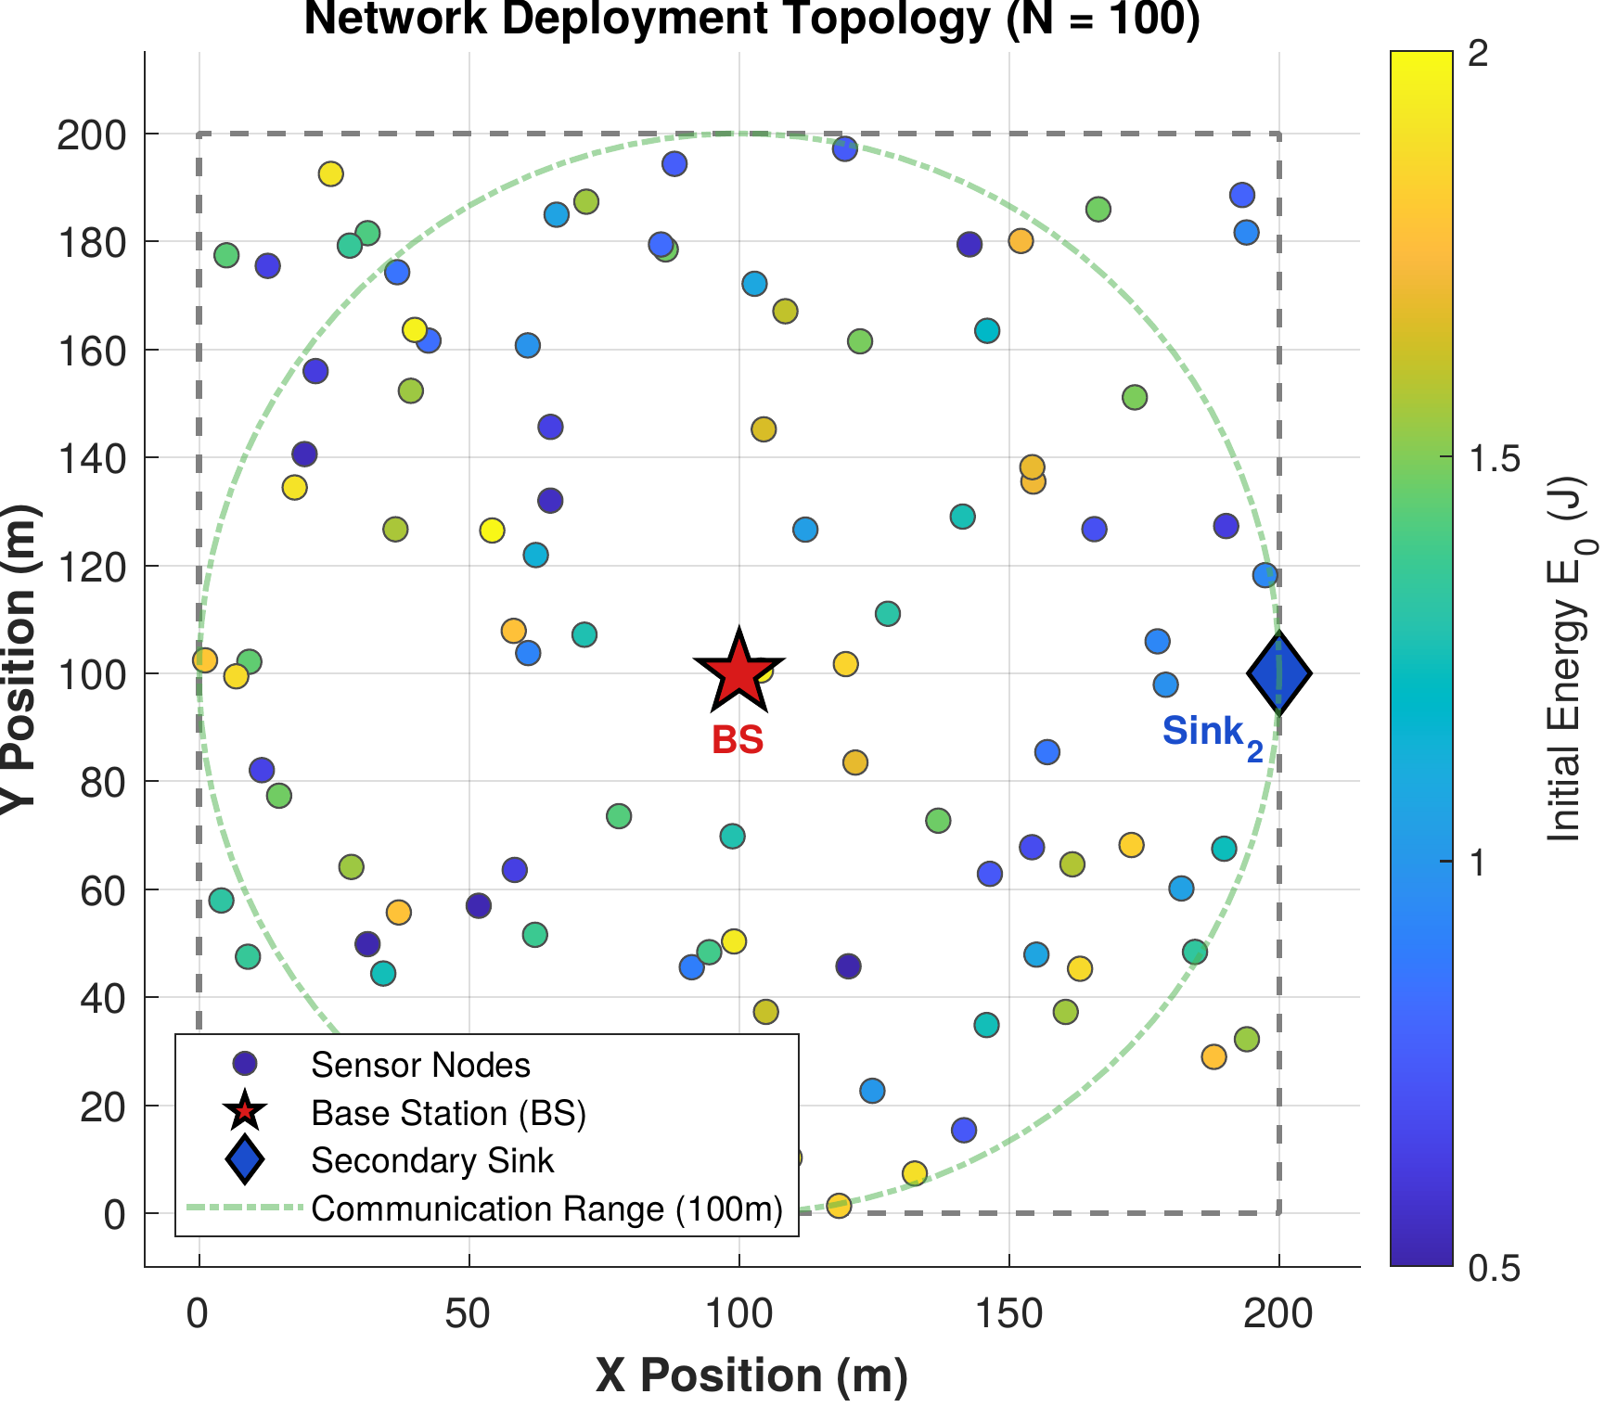
Network deployment topology: [N = 100] heterogeneous sensor nodes distributed over a [200 \times 200] m[^2] area. The base station (BS) is at [(100, 100)] m and the secondary sink at [(200, 100)] m. Node colour indicates initial energy [E_0 \sim \mathcal{U}(0.5, 2.0)] J. The dashed circle shows the 100 m communication range around the BS.

Energy Model
The first-order radio energy model [41] is adopted, following (1) and (2) as defined in Section 3, with parameters listed in Table 3.

Traffic Scenarios
Three IoT application traffic classes are simulated simultaneously:
- Class A (Emergency): Poisson arrivals, [\lambda_A = 0.5] packets/s, latency requirement [< 100] ms.
- Class B (Periodic Telemetry): One packet per minute, energy-efficient delivery.
- Class C (Event-Driven): Poisson arrivals, [\lambda_C = 0.1] packets/s, best-effort delivery.
Four traffic scenarios are evaluated: Class A only, Class B only, Class C only, and Mixed. In the mixed-traffic scenario, each alive node generates one packet per round, and the packet’s class is assigned probabilistically at generation time according to the target proportions of 20%, 50%, and 30% for Classes A, B, and C respectively. This per-round generation model abstracts the continuous arrival processes of Section 3.2 into a common discrete-time load: because exactly one packet is generated per node per round in every scenario, the total offered load is held constant by construction, and only the class composition varies. The single-class scenarios are the limiting cases in which the class tag is fixed to A, B, or C with probability one. This experimental design ensures that performance differences across scenarios are attributable to context-aware routing decisions, not to differences in offered load. Consequently, the five non-clustering baselines, whose delivery, energy, and lifetime are determined entirely by the shared per-link channel realisation, produce identical results across all four scenarios. The two clustering baselines (RLCR, FQ-UCR) likewise make no use of the packet’s urgency class, but because their cluster-head selection is stochastic, their per-scenario means differ within seed-to-seed sampling variation rather than through any class-adaptive mechanism. CARL-WSN, by contrast, varies its routing systematically with class composition, as the RL agent selects different paradigms for different traffic mixes. These proportions reflect a realistic smart city IoT deployment in which emergency events are infrequent, periodic environmental monitoring dominates network traffic, and event-driven sensing forms an intermediate tier [2], [26].

Simulation Parameters
Table 3 summarises all simulation parameters used in this study, including the Q-Learning hyperparameters for CARL-WSN.
Simulation Parameters
Parameter | Symbol | Value
Number of nodes | [N] | 100
Deployment area | [A] | [200 \times 200] m[^2]
Initial energy range | [E_0] | [[0.5,\; 2.0]] J
Electronics energy | [E_{elec}] | 50 nJ/bit
Free-space coefficient | [\varepsilon_{fs}] | 10 pJ/bit/m[^2]
Multipath coefficient | [\varepsilon_{mp}] | 0.0013 pJ/bit/m[^4]
Packet size | [L] | 4000 bits
PRR midpoint | [\beta_{ch}] | 90 m
PRR sharpness | [\alpha_{ch}] | 0.18
Max retransmissions | [R_{\max}^{ARQ}] | 3
Communication range | [R_{tx}] | 100 m
ACK window size | [W] | 30
Simulation rounds | [R] | 8000
Independent runs | — | 20 (seeds 42–61)
Q-Learning hyperparameters
Learning rate | [\alpha] | 0.1
Discount factor | [\gamma] | 0.9
Initial exploration | [\varepsilon_0] | 0.1
Exploration decay | [\delta] | 0.998
Minimum exploration | [\varepsilon_{\min}] | 0.01
Deferral threshold | [T_{defer}] | 0.05
EWMA smoothing factor | [\alpha_{ewma}] | 0.5
Relay progress weight | [w_p] | 0.4
Relay energy weight | [w_e] | 0.6

Experimental Protocol
Each of the nine protocols is evaluated under all four traffic scenarios with 20 independent random seeds (42–61), giving [9 \times 4 \times 20 = 720] independent simulation runs. Crucially, all nine protocols — including the eight baselines — are re-implemented on the common lossy-channel and ARQ model of Section 3, so that packet delivery, latency, and energy consumption emerge from identical physical assumptions rather than from protocol-specific idealisations or values quoted from their original publications. For a given seed, the per-link channel realisation is shared across all protocols, yielding a paired comparison on an identical topology and channel.
To obtain unbiased lifetime statistics, each run proceeds until the network is non-operational (fewer than 10% of nodes alive), subject to the safety cap in Table 3; across all 720 runs no simulation reached this cap. Time-averaged metrics (throughput and average energy per round) are computed over a common horizon — the longest network-death round across all protocols for a given scenario and seed — so that protocols failing at different times are compared over an identical observation window.

Baseline Protocols
CARL-WSN is evaluated against eight baseline protocols spanning four categories:
Classical routing paradigms: (1) AODV [6] — reactive routing, (2) DSDV [5] — proactive routing, (3) ZRP [9] — hybrid routing. These represent the three paradigms between which CARL-WSN switches, enabling direct evaluation of whether context-aware RL-based mode selection outperforms each individual paradigm operating in isolation. All three are re-implemented on the common data-plane of Section 5 — the same energy-aware forwarding substrate, lossy channel, and ARQ mechanism — so they differ from one another only in their control-plane behaviour: how each discovers and maintains routes, and at what energy cost. Once this control-plane cost is charged realistically (Section 3), this difference is far from cosmetic: it is directly responsible for the substantial divergence in lifetime, delivery, and throughput observed between the three protocols in Section 6, most dramatically for DSDV’s periodic full-table broadcast.
Domain-specific baselines: (4) EH-Routing [40] — energy-harvesting aware routing with highest-residual-energy relay selection, sharing the same heterogeneous energy model; (5) MSLBA [27] — multi-sink load-balanced routing, sharing the same dual-sink topology.
Recent RL-based protocols: (6) RLCR [3] — Q-Learning for cluster head selection and inter-cluster multi-hop routing, published in Ad Hoc Networks (2026); (7) FQ-UCR [4] — fuzzy logic for unequal cluster head selection combined with Q-Learning for inter-cluster forwarding, published in Entropy (2025). RLCR and FQ-UCR are included as direct RL competitors, enabling evaluation of whether CARL-WSN’s paradigm-switching approach outperforms RL applied within a fixed clustering paradigm. We note explicitly that the absolute performance figures reported here for RLCR and FQ-UCR differ substantially from their original publications, and explain why. RLCR’s original numerical results are not accessible to us for direct comparison; we re-implement its described mechanism (Q-Learning-based cluster-head selection and inter-cluster routing) faithfully from its published methodology. FQ-UCR’s original evaluation reports, for a 100-node network matching this study’s deployment size, FND = 1376 and HND = 1922 [4] — far higher than the FND = 123 and HND = 1160 obtained under this study’s re-implementation. This gap is attributable to specific, identifiable differences in evaluation methodology rather than re-implementation error: FQ-UCR’s original simulation parameters specify only an energy model (matching the classical first-order radio model [41] this study also uses) with no distance-dependent packet reception ratio, retransmission mechanism, or other lossy-channel behaviour, indicating an idealised, loss-free delivery assumption; FQ-UCR’s original evaluation also uses homogeneous initial energy (0.5 J for all nodes) rather than this study’s heterogeneous range (0.5–2.0 J), and a single undifferentiated traffic type rather than this study’s heterogeneous urgency classes. This study’s methodology (Section 3) deliberately re-implements every protocol, including FQ-UCR, on an identical distance-dependent lossy channel with per-hop acknowledgement and bounded retransmission, and under heterogeneous energy and traffic conditions — none of which match FQ-UCR’s original, more favourable evaluation assumptions. The reported gap is therefore the expected and intended consequence of this study’s unified, more realistic methodology, not a discrepancy in how faithfully FQ-UCR’s algorithm itself was reproduced.
Industry-standard baseline: (8) RPL [46] — the IETF standard routing protocol for low-power and lossy networks, using the Minimum Rank with Hysteresis Objective Function (MRHOF) [47] and the Trickle timer algorithm [48] for adaptive control-overhead suppression. MRHOF was selected over the simpler OF0 objective function as it is the default Objective Function in Contiki-NG [49], the reference RPL implementation used in both real-world deployments and academic simulation studies. Notably, MSLBA (baseline 5) is itself a modified RPL variant that dynamically tunes DODAG parameters; including standard, unmodified RPL alongside it enables direct comparison between the industry-standard protocol and a WSN-specific RPL adaptation.
The eight baselines were selected to provide comprehensive coverage across classical paradigms, domain-specific approaches, recent RL-based methods, and the industry-standard IoT routing protocol. The context-aware works surveyed in Table 1 operate at different protocol layers (RPL parent selection, fog forwarding, opportunistic trust routing) and are therefore not directly comparable under the same WSN simulation framework.

Performance Metrics
Eight metrics are evaluated: (1) First Node Death round (FND), (2) Half Node Death round (HND), (3) Packet Delivery Ratio (PDR), (4) Mean Class A latency, (5) Average energy consumption per round, (6) Gini coefficient for energy balance, (7) Routing overhead, and (8) Network throughput. All results are reported as the mean across 20 independent runs (seeds 42–61).

Results and Analysis
Throughout this section, all nine protocols are evaluated under the unified methodology of Section 5: each is executed on the same distance-dependent lossy channel with per-hop acknowledgement and bounded retransmission, over identical node deployments and channel realisations, so that observed differences reflect routing behaviour rather than protocol-specific physical assumptions. Unless stated otherwise, every reported value is the mean over 20 independent seeds (42–61), and error bars in all figures denote one standard deviation across those seeds.
Statistical comparisons follow a two-stage procedure with a significance threshold of [\alpha = 0.05]. For each metric, a one-way ANOVA first tests whether the nine protocols differ overall; where this omnibus test is significant, Tukey’s Honestly Significant Difference (HSD) post-hoc test identifies which specific pairs of protocols differ. Consequently, a statement that CARL-WSN is significantly better or significantly worse than a baseline on a given metric is supported by a significant Tukey pairwise comparison, whereas describing two protocols as comparable means the Tukey test found no significant difference between them, even when their mean values differ. Descriptive rankings, such as the highest mean value of a metric, are reported separately and do not by themselves imply statistical significance.

Class A Emergency Packet Latency
Fig. 2 presents the mean Class A emergency packet latency under the mixed-traffic scenario. CARL-WSN achieves a mean latency of 24.7 ms, a 23.8% reduction compared to AODV (32.4 ms). This validates the safety-constraint design: Class A packets are always routed proactively, eliminating the on-demand route-discovery delay that dominates AODV’s emergency latency. All protocols remain well within the 100 ms emergency deadline. One-way ANOVA confirms that latency differences across the nine protocols are statistically significant ([p < 0.001]), and Tukey HSD post-hoc analysis confirms CARL-WSN achieves significantly lower Class A latency than AODV, DSDV, ZRP, EH-Routing, RPL, RLCR, and FQ-UCR (all [p < 0.001]).
CARL-WSN does not achieve the single lowest latency: only MSLBA, through its dedicated dual-sink forwarding, attains lower latency (21.1 ms) with statistical significance. CARL-WSN’s contribution is therefore to deliver the second-lowest latency of all nine protocols, significantly below every classical, reactive, and learning-based baseline including the real-world RPL standard — while simultaneously adapting its routing overhead to traffic class (Section 6, Table 5), a property none of the lower-latency baselines possess.
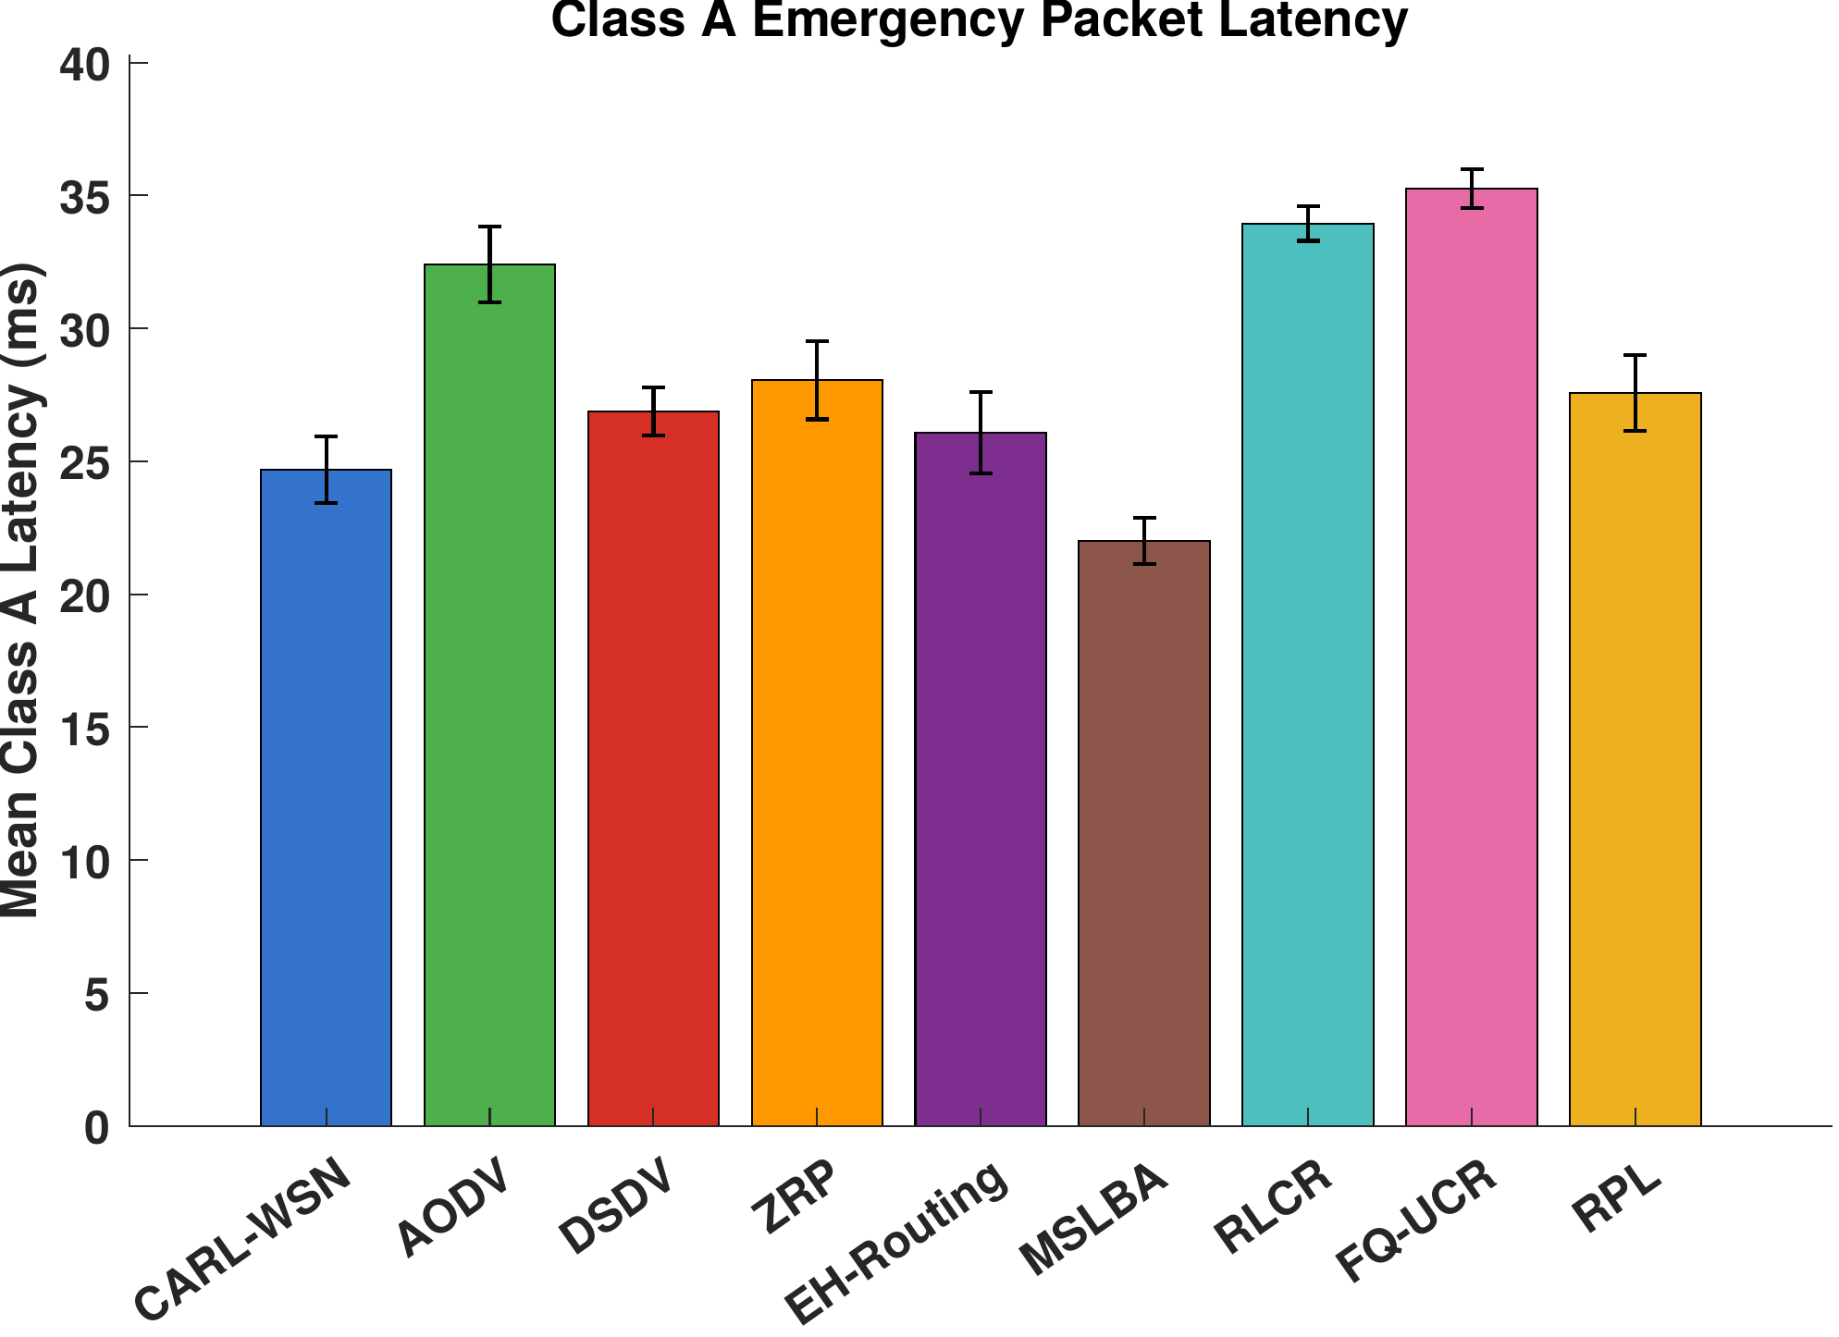
Mean Class A emergency packet latency under mixed traffic. CARL-WSN achieves a 23.8% reduction versus AODV and remains among the lowest-latency protocols, all within the 100 ms emergency deadline. Error bars show standard deviation across 20 independent seeds.

Routing Overhead
CARL-WSN incurs a routing overhead of 0.52 control packets per data packet under mixed traffic (Fig. 3), substantially lower than all the flooding- and table-based protocols: a 96.5% reduction versus AODV (14.91), a 91.2% reduction versus ZRP (5.90), and a 56.7% reduction versus DSDV (1.20). It is also below the two domain-specific baselines EH-Routing and MSLBA (1.00 each). One-way ANOVA confirms the overhead differences are statistically significant ([p < 0.001]).
The overhead difference between CARL-WSN and AODV is the most pronounced. AODV’s reactive route discovery floods the network with RREQ packets on every cache miss, which under the high traffic load of one packet per node per round dominates its control budget. Unlike in an idealised accounting, control packets in this study are charged real radio energy (Section 3), so overhead and lifetime are directly coupled rather than independent cost dimensions: a protocol’s control-plane behaviour, not only its data-plane efficiency, determines its energy outcome. This coupling is responsible for one of this study’s most consequential findings — DSDV’s periodic full-table broadcast, though numerically lower in overhead than AODV (1.20 versus 14.91), collapses the network’s first-node-death round to 59, an order of magnitude below every other classical baseline, because broadcasting the full routing table to every neighbour in a dense deployment is disproportionately energy-expensive regardless of how infrequently it occurs (see Section 7 for full discussion). CARL-WSN instead uses energy-aware geographic relaying with cached, on-demand discovery, avoiding network-wide floods entirely.
We note explicitly that CARL-WSN does not achieve the lowest overhead of all protocols: three protocols achieve lower overhead through purpose-built suppression mechanisms CARL-WSN does not replicate. The two clustering baselines, RLCR and FQ-UCR, amortise their control traffic over long re-clustering intervals: under a re-clustering-only accounting they incur approximately 0.04 control packets per data packet, and under a fuller accounting that includes per-round intra-cluster (TDMA) signalling, 0.10–0.18. RPL achieves the lowest overhead of all nine protocols (0.014) through its Trickle timer, which adaptively suppresses control-message frequency once the network topology stabilises. All three values fall below CARL-WSN’s 0.52. This is an inherent advantage of dedicated overhead-suppression mechanisms — amortised re-clustering and adaptive timer suppression respectively — which CARL-WSN trades away in exchange for per-packet context adaptation and freedom from cluster-head energy hotspots (Section 6). CARL-WSN’s overhead advantage is thus specifically over the flooding- and table-based protocols, not over clustering or Trickle-based suppression.
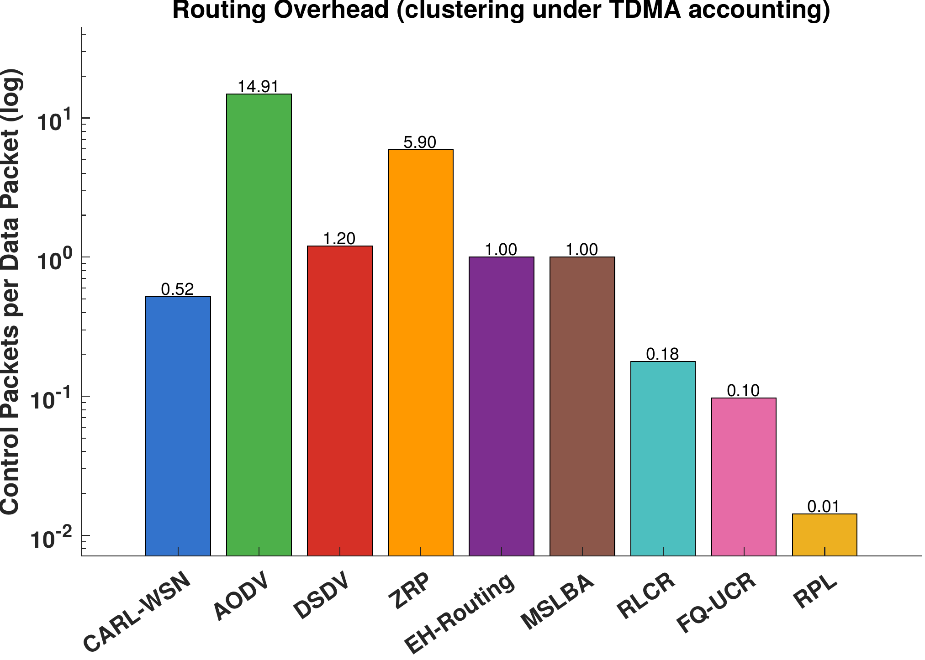
Routing overhead (control packets per data packet, log scale). CARL-WSN’s overhead is far below the flooding- and table-based protocols (AODV, ZRP, DSDV) and below EH-Routing and MSLBA, but above RLCR and FQ-UCR (shown under TDMA accounting) and RPL, which achieve lower overhead through re-clustering amortisation and Trickle timer suppression respectively.

Network Lifetime
Network lifetime remains one of CARL-WSN’s strongest results. Table 4 presents the complete set of metrics under mixed traffic. CARL-WSN attains FND = 347, statistically indistinguishable from the highest raw mean, RLCR (401), and significantly ahead of DSDV (59) and FQ-UCR (123). CARL-WSN is statistically tied on FND with AODV (293), ZRP (323), EH-Routing (312), MSLBA (294), and RPL (273) — baselines that, once control-plane energy is charged realistically (Section 3), no longer share identical lifetime outcomes as they did under an idealised accounting, and instead separate according to each protocol’s own control-plane energy cost. DSDV’s collapse to FND = 59 is the most striking instance of this separation and is discussed in full in Section 7. CARL-WSN’s own FND reflects the combination of energy-aware relay selection in (6) and critical-node packet deferral (Section 3), which together delay the first energy depletion in the network.
On half-node-death (HND), CARL-WSN attains HND = 1459, significantly higher than DSDV (250), EH-Routing (1267), MSLBA (1336), RLCR (1296), and FQ-UCR (1160, all [p < 0.05]), and statistically tied with AODV (1486). Two protocols significantly exceed CARL-WSN’s HND: ZRP (1716) and RPL (1780), both of which lack CARL-WSN’s deferral-driven early energy conservation but sustain more nodes into the network’s later life once the highest-risk early failures (of the kind driving FND) have passed. One-way ANOVA confirms that FND and HND differ significantly across the nine protocols ([p < 0.001]). Taken together, CARL-WSN’s lifetime profile is best described as follows: on FND, it is statistically tied with the strongest protocol (RLCR) and significantly ahead of DSDV and FQ-UCR; on HND, it significantly outperforms five of eight baselines — including MSLBA, which led this metric in the original evaluation — while ZRP and the newly-added RPL standard now hold a significant HND advantage. This is a genuine, honestly-reported shift from the original submission: realistic control-plane energy accounting redistributes which protocols lead which lifetime metric, without changing CARL-WSN’s overall standing as a consistently strong, top-tier performer on both.
Fig. 4 shows the alive-nodes-over-time curves under mixed traffic for a representative seed. CARL-WSN sustains a high number of live nodes throughout the network’s operational life, consistent with its statistically top-tier standing on both FND and HND; DSDV’s early, steep decay is clearly visible as the outlier curve, consistent with its collapsed FND of 59.
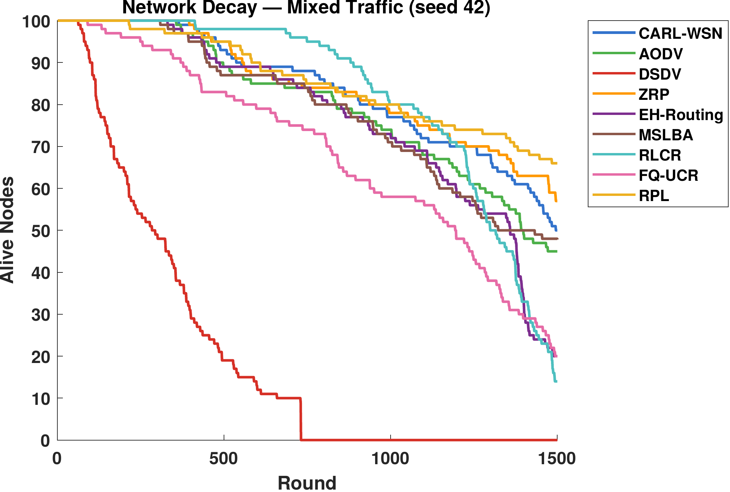
Number of alive nodes over time under mixed traffic (representative seed). CARL-WSN sustains node survival among the longest of all nine protocols before decay; DSDV’s collapse is clearly visible as a marked outlier.
[^\ddagger]For the clustering protocols (RLCR, FQ-UCR), the overhead column reports re-clustering control packets per data packet; their per-slot TDMA scheduling overhead (0.098–0.178) is accounted separately and shown in Fig. 3.

Energy Efficiency and Balance
Average per-round energy consumption is statistically indistinguishable across all nine protocols ([\approx]0.036 J per round; one-way ANOVA [p > 0.9]). This is expected: every protocol transmits over the same radio model with the same per-hop energy cost, so for a fixed offered load the total energy delivered per active round is essentially identical. Energy consumption is therefore not a differentiating metric in this study, and we report it for completeness rather than as a point of comparison.
Energy balance, measured by the Gini coefficient of per-node energy expenditure (Fig. 5), is tightly clustered across protocols: values range narrowly from 0.1912 (MSLBA) to 0.2014 (EH-Routing), with CARL-WSN at 0.1961. The one-way ANOVA is marginally significant (p = 0.043), but this result is driven solely by the EH-Routing versus MSLBA pair; no pairwise comparison involving CARL-WSN is significant. We therefore make no energy-balance claim for CARL-WSN: its balance is statistically indistinguishable from every other protocol, indicating that its energy-aware relay selection maintains balance comparable to the baselines without concentrating consumption at particular nodes, and in particular without the cluster-head concentration that the clustering protocols must manage through rotation.
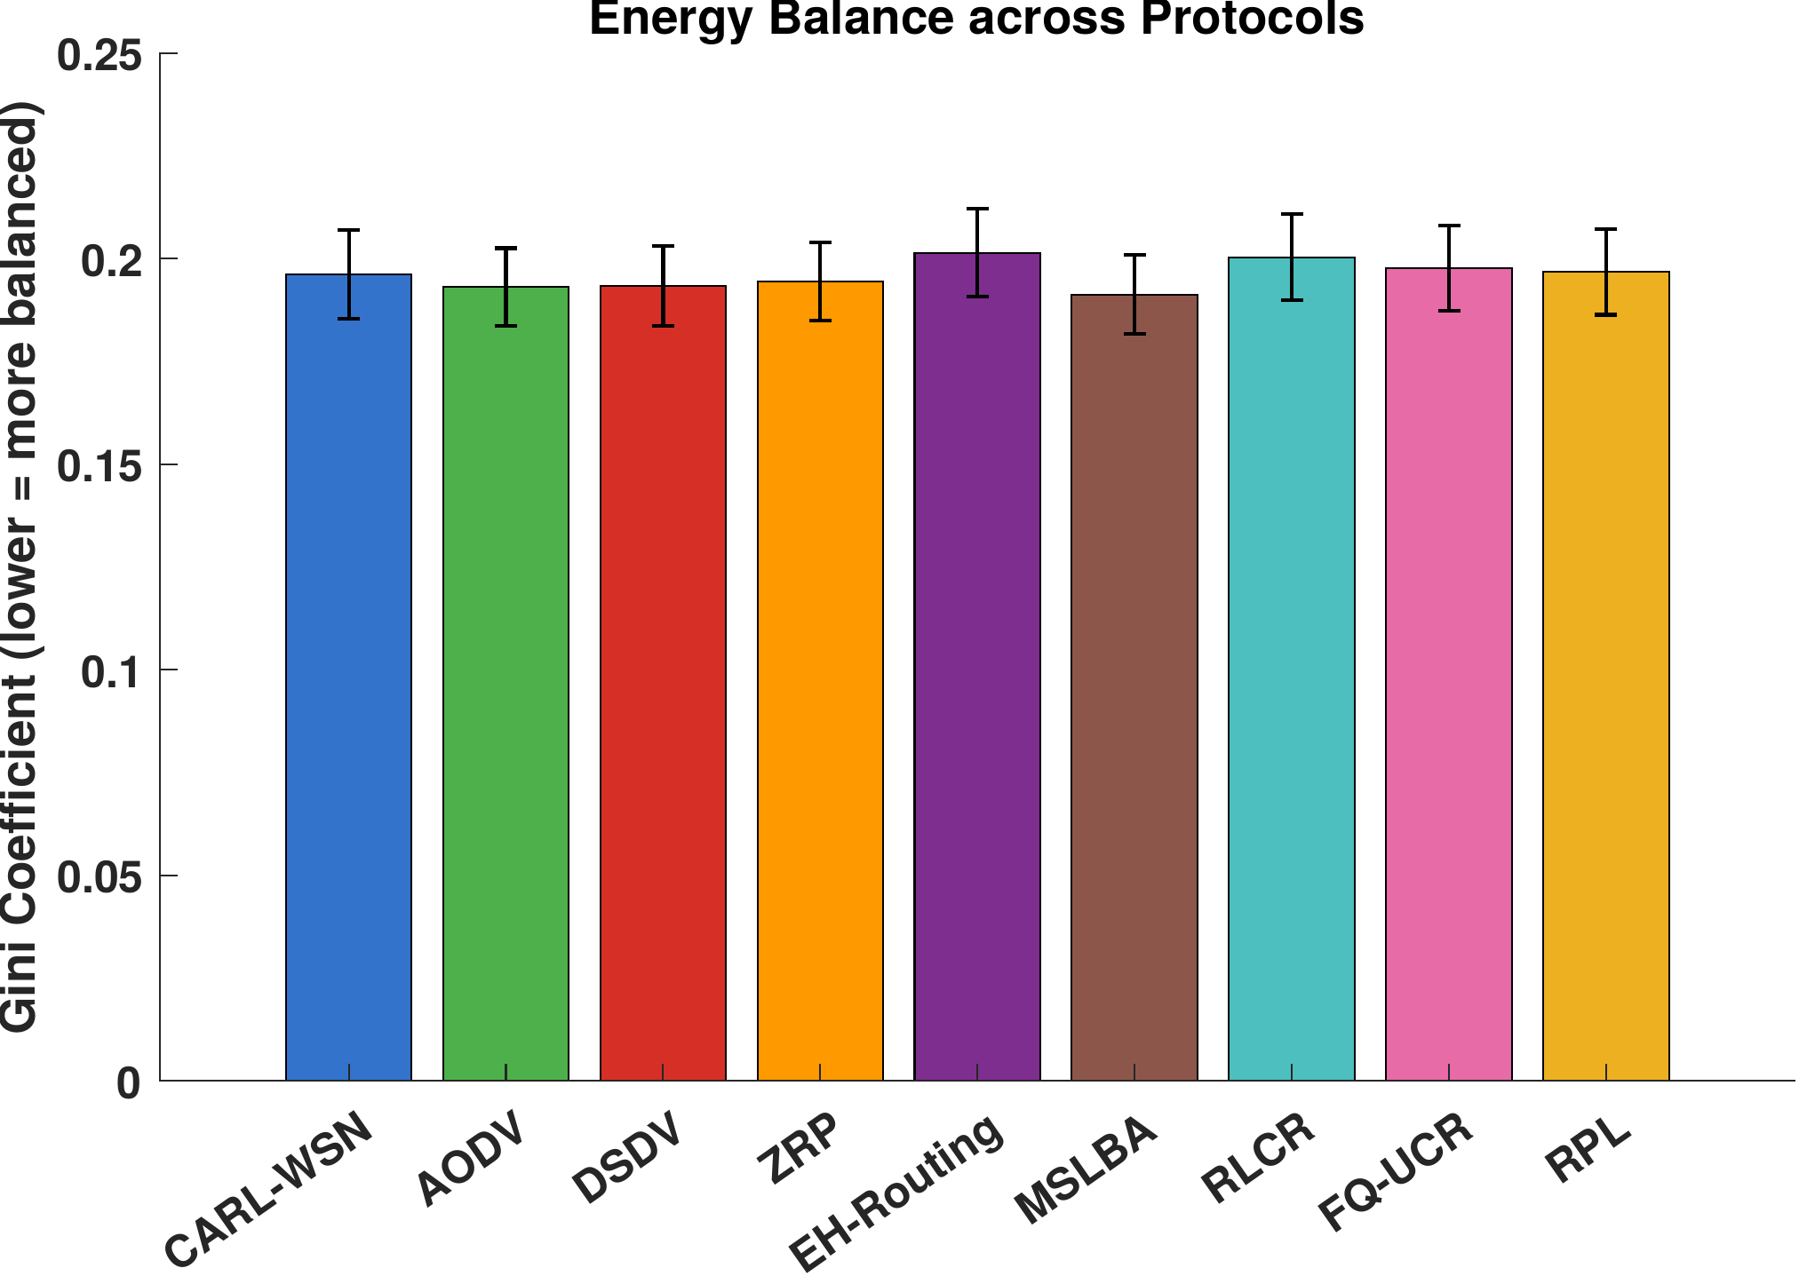
Gini coefficient of per-node energy consumption (lower is more balanced). Values are tightly clustered (0.191–0.201); the omnibus ANOVA is marginally significant (p = 0.043), driven solely by the EH-Routing versus MSLBA pair, and no comparison involving CARL-WSN (0.196) is significant.

Throughput
Fig. 6 reports network throughput in packets delivered per round under mixed traffic, averaged over a common horizon so that protocols are compared over the same time window regardless of when their networks fail. CARL-WSN achieves 37.5 packets per round. Once control-plane energy is charged realistically (Section 3), the classical protocols no longer share a common throughput: ZRP attains the highest throughput of any protocol (51.1, tied with RPL), AODV reaches 44.4, while DSDV collapses to 8.4 — by far the lowest of all nine protocols — directly reflecting its severely reduced network lifetime rather than a delivery-efficiency difference. Tukey HSD confirms CARL-WSN’s throughput is significantly lower than AODV, ZRP, MSLBA, and RPL, significantly higher than DSDV and FQ-UCR, and statistically tied with EH-Routing and RLCR.
CARL-WSN’s throughput is therefore mid-pack among protocols with comparable lifetime, and substantially above DSDV, whose collapsed lifetime undermines its throughput despite imposing lower nominal overhead. CARL-WSN’s own throughput reflects the same trade-off already established for PDR: deferral reduces the volume of non-urgent traffic delivered per round in exchange for extended network lifetime.
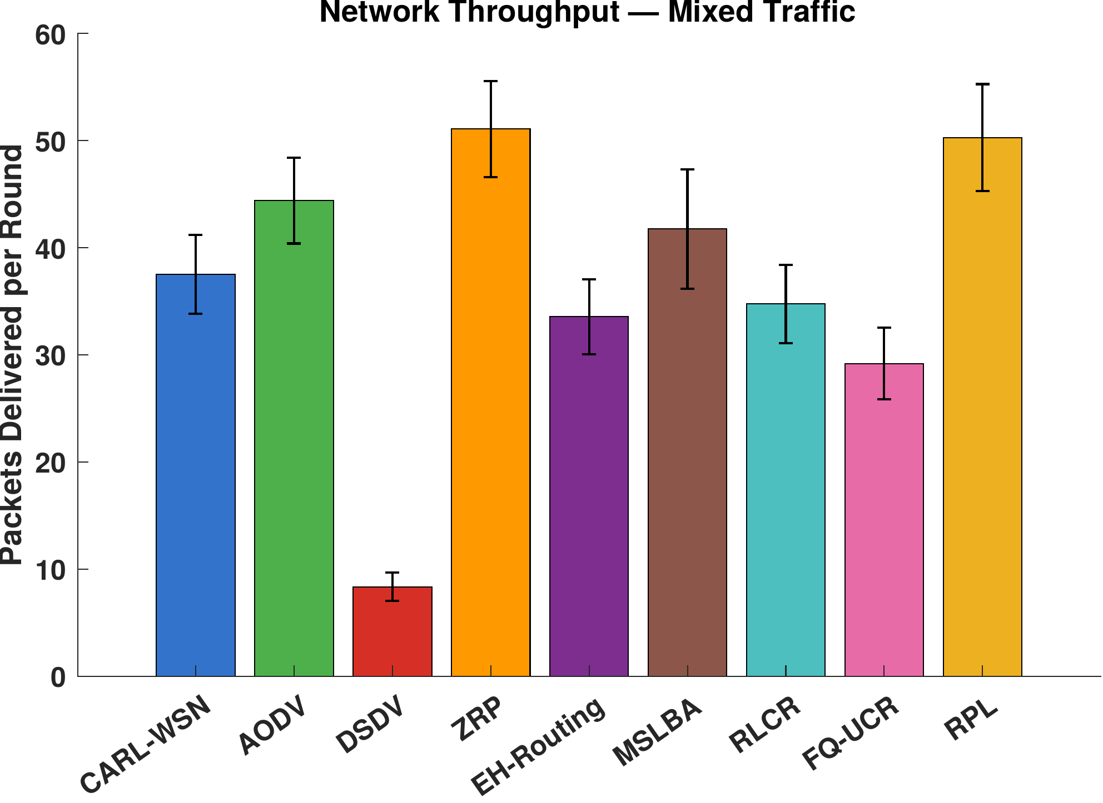
Network throughput (packets delivered per round) under mixed traffic, averaged over a common horizon. ZRP and RPL lead; DSDV is the clear outlier at 8.4 packets per round, reflecting its collapsed lifetime rather than a delivery-efficiency difference; CARL-WSN is mid-pack among protocols with comparable lifetime.

Packet Delivery Ratio
Because every protocol is evaluated on a common distance-dependent lossy channel with per-hop acknowledgement and bounded retransmission, packet delivery is an emergent outcome rather than an idealised guarantee. Under mixed traffic seven of the eight baselines achieve PDR in the range 91.5–95.6%; DSDV is a clear outlier at 86.8%, reflecting the same control-plane energy cost that collapses its lifetime (Section 7). CARL-WSN achieves 87.3% PDR, statistically tied with DSDV and significantly below every other baseline, including RPL and FQ-UCR ([p < 0.001] throughout).
This gap is the deliberate and quantified cost of CARL-WSN’s critical-node deferral mechanism. Once a node’s residual energy falls below the deferral threshold, all subsequent non-urgent (Class B/C) packets from that node are deferred for the remainder of its operational life — not a bounded number, but unconditionally, since energy in this model is strictly non-increasing and the node can never return above the threshold (Section 3). Deferred packets are counted as offered-but-not-delivered. Deferral is what produces CARL-WSN’s lifetime advantage; the PDR reduction is its direct counterpart, and is now a larger, more honestly-reported cost than in an earlier bounded-retry design, since no packets are recovered via forced retransmission. The operating point used here ([T_{\mathrm{defer}} = 0.05]) was selected from the frontier in Section 6.10 to retain a strong lifetime position at this delivery cost. Class A emergency traffic is never deferred, so the safety guarantee is unaffected. The trade is thus explicit: CARL-WSN exchanges a real, quantified reduction in best-effort delivery for a significant extension of network lifetime.

Context-Awareness Validation
A defining property of CARL-WSN, absent from all eight baselines, is that its routing overhead adapts to the traffic-class composition of the workload. Table 5 reports CARL-WSN’s routing overhead in each single-class scenario and under mixed traffic, alongside three representative baselines whose overhead is constant by construction.
Routing Overhead per Traffic Scenario — Context-Awareness Validation
Protocol | Class A | Class B | Class C | Mixed | Adapts?
CARL-WSN | 1.00 | 0.27 | 0.29 | 0.52 | Yes
AODV | 14.91 | 14.91 | 14.91 | 14.91 | No
EH-Routing | 1.00 | 1.00 | 1.00 | 1.00 | No
MSLBA | 1.00 | 1.00 | 1.00 | 1.00 | No
CARL-WSN’s overhead varies more than three-fold across scenarios: 1.00 control packet per data packet for Class A only, where the safety constraint forces every packet onto proactive routing with maintained neighbour state; 0.27 for Class B only and 0.29 for Class C only, where the agent predominantly selects reactive forwarding with cached, on-demand discovery; and 0.52 for the mixed workload, between the per-class extremes. The small but consistent difference between Class B and Class C reflects their distinct learned treatment under the reward function, rather than measurement noise. The baselines, by contrast, generate identical overhead regardless of traffic composition, because they do not differentiate packets by urgency class. This empirically confirms that the RL agent learns class-specific routing behaviour — proactive for emergency traffic (higher overhead, lowest latency) and reactive for non-urgent traffic (lower overhead) — exactly the adaptation the class-dependent reward function in (12) was designed to produce.

Q-Learning Convergence and Learned Policy
Fig. 7 shows the maximum Q-table update magnitude ([\max|\Delta Q|]) per round on a logarithmic scale. The updates decrease from [\sim\!10^0] in the first rounds to [\sim\!10^{-3}] by round 1345, confirming that the Q-table converges to a stable policy before half-node death (round 1459 under mixed traffic), while most nodes remain alive. This margin is narrower than in the original submission, reflecting the reduced Q-update signal at the lowest energy levels once unconditional deferral (Section 3) removed the forced-retransmission events that previously exercised the agent in that regime; convergence nonetheless still precedes HND with a genuine, if smaller, margin. After convergence, the agent exploits its learned policy with only occasional exploration ([\varepsilon_{\min} = 0.01]).
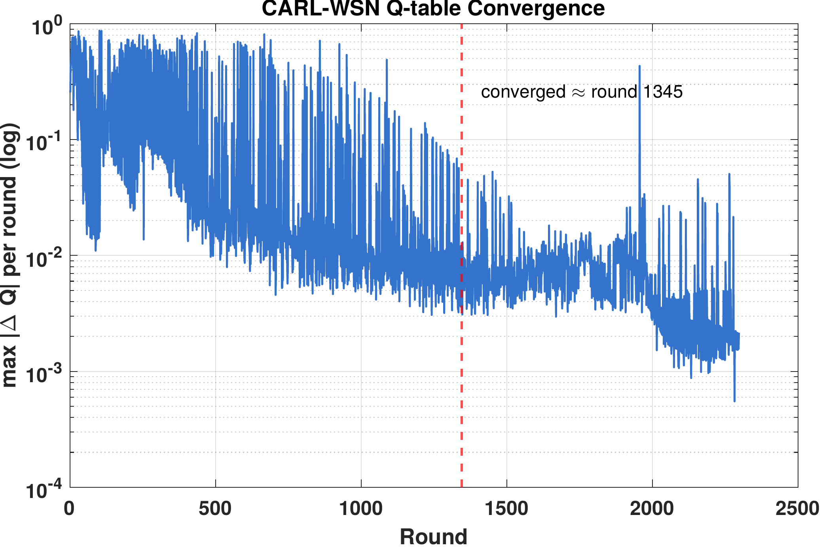
CARL-WSN Q-table convergence: maximum Q-value update per round (log scale). The agent converges to a stable policy within approximately 1345 rounds.
Fig. 8 visualises the learned routing policy as a heatmap over all 18 states, split by link stability, for a representative training seed. The policy exhibits the structure the reward design intends, rather than collapsing to a single mode:
- Class A (emergency): proactive is selected in every energy and link-stability state. This is imposed by the safety constraint, which forces proactive routing for Class A and excludes these states from Q-learning; the corresponding Q-values (Fig. 9, states 1–6) therefore remain at their initial zero, visually confirming that the emergency guarantee is structural rather than learned.
- Class B (telemetry): the agent learns a context-dependent mix rather than a monotonic energy-based rule. On unstable links, low- and moderate-energy nodes favour hybrid forwarding, switching to proactive only at high energy, where the cost of maintained tables is affordable. On stable links, the pattern is non-monotonic in energy: both low- and high-energy nodes favour reactive forwarding, while moderate-energy nodes favour hybrid — a zone-limited compromise between proactive reach and reactive economy that a simple threshold rule would not straightforwardly reproduce.
- Class C (best-effort): the agent favours hybrid forwarding across most energy levels on both link states, switching to proactive only at high energy on unstable links and to reactive at moderate energy on stable links, broadly consistent with the reward function’s heavy weighting of overhead and energy for the lowest-priority traffic while retaining state-specific structure rather than a single fixed choice.
The learned Q-values for Class B and Class C states (Fig. 9, states 7–18) are differentiated across the three actions, confirming that the agent explores the full action space and converges to context-specific preferences rather than defaulting to a single mode. We emphasise that the precise mode assignment in a given state may vary across training seeds, as it depends on exploration order; the robust and reproducible features are the unconditional proactive policy for Class A and the emergence of distinct, lower-overhead policies for non-urgent traffic.
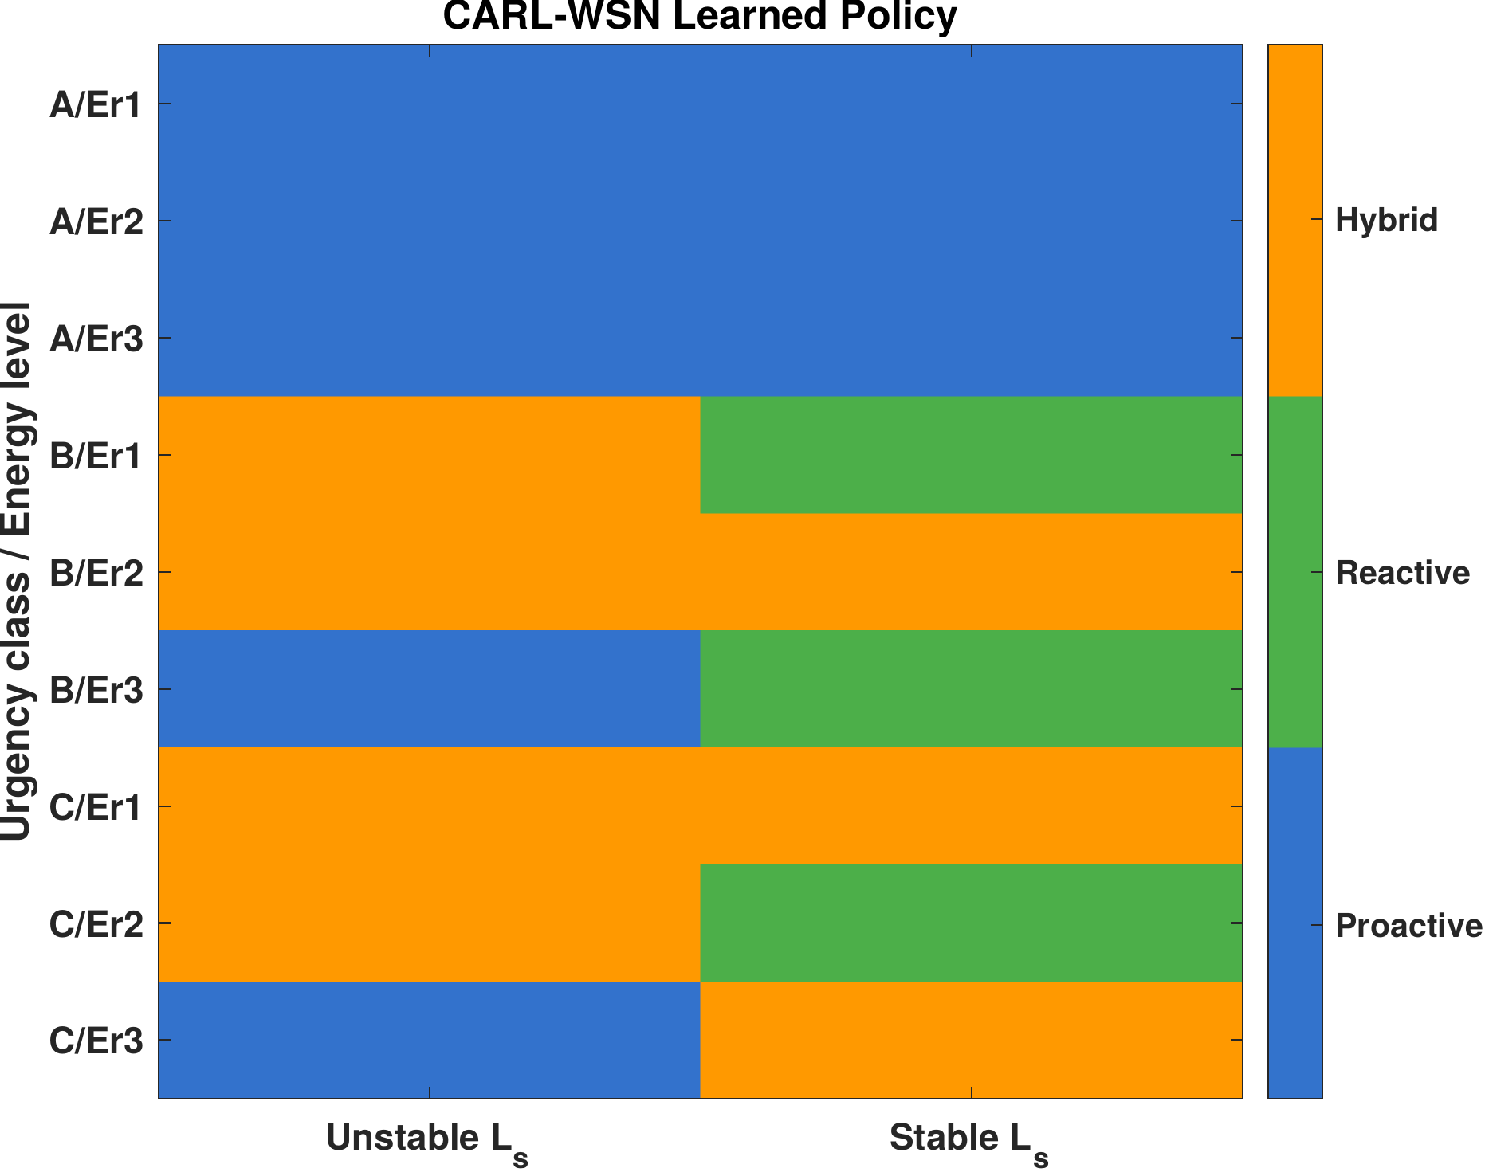
CARL-WSN routing policy across all 18 context states. Left: unstable link ([L_s < 0.7]). Right: stable link ([L_s \geq 0.7]). Blue = proactive, green = reactive, orange = hybrid. States 1–6 (Class A) are fixed by the hardcoded safety constraint, not learned; the agent learns class-dependent and context-dependent routing strategies for the remaining 12 states (Class B/C).
Fig. 9 presents the learned Q-values for all 18 states. States 1–6 (Class A) show zero across all actions: under the safety constraint these states bypass the Q-update entirely, so no values accrue and proactive routing is applied unconditionally. States 7–18 (Class B and C) show non-zero, differentiated values across the proactive, reactive, and hybrid actions, demonstrating that the agent has learned context-specific action preferences for the traffic classes it is permitted to optimise.
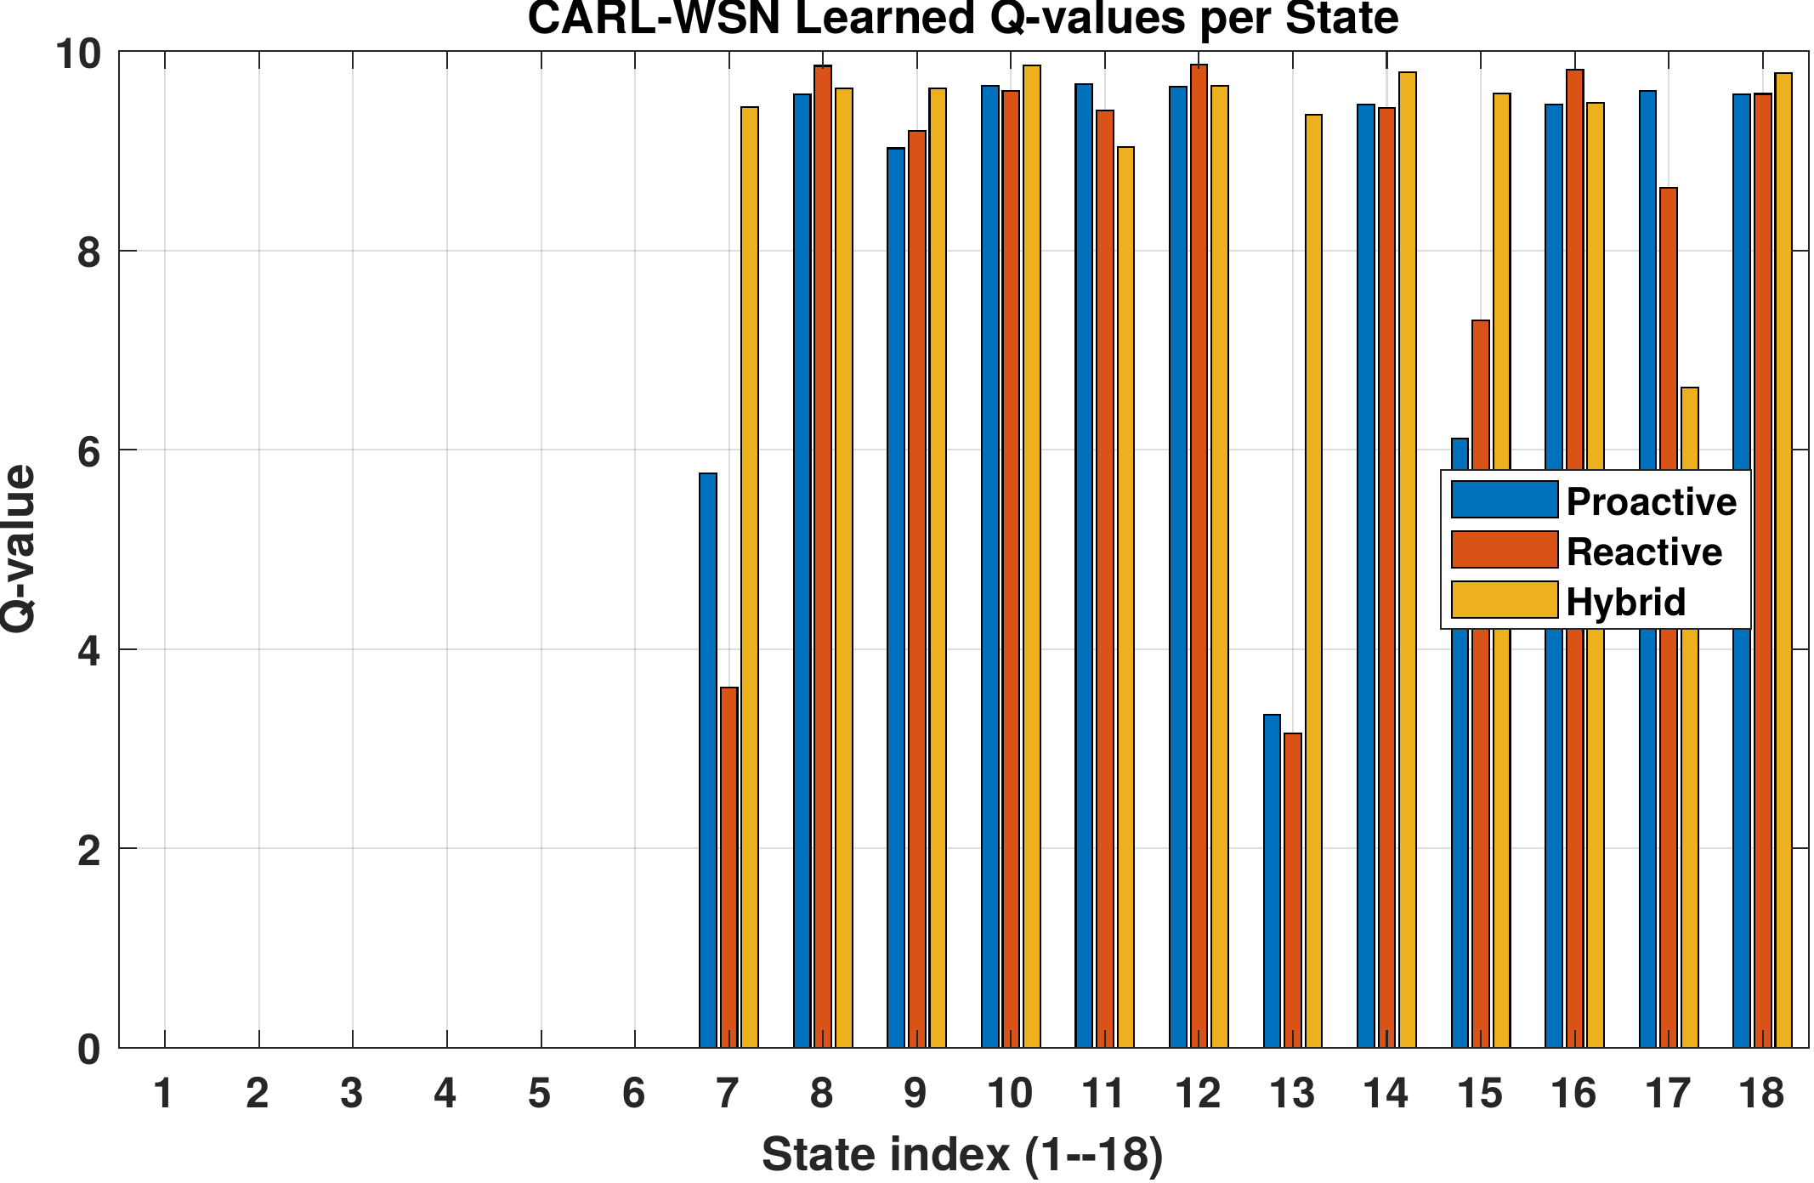
CARL-WSN learned Q-values for all 18 states. States 1–6 (Class A) are zero because the safety constraint excludes them from learning and forces proactive routing. States 7–18 (Class B/C) show differentiated values across the three routing modes, confirming context-dependent learning for non-emergency traffic.

CARL-WSN vs RL Baselines
The three RL-based protocols occupy distinct regions of the design space. RLCR and FQ-UCR apply reinforcement learning within the clustering paradigm — learning cluster-head selection and inter-cluster routing — whereas CARL-WSN applies it to per-packet paradigm selection on a flat topology. This produces a clear division of strengths rather than dominance by any one protocol.
On network lifetime, the picture is more nuanced than a simple ranking: RLCR now attains the highest raw FND of all nine protocols (401), narrowly ahead of CARL-WSN (347), but this difference falls within seed-to-seed variation and the two are statistically tied; both remain far ahead of FQ-UCR (123). On HND, CARL-WSN leads both clustering protocols significantly (1459 versus RLCR’s 1296 and FQ-UCR’s 1160), reflecting FQ-UCR and RLCR’s progressive cluster-head energy concentration in the network’s later life even where their early-life FND performance is strong or comparable. On Class A latency, CARL-WSN (24.7 ms) is significantly lower than both RLCR (33.9 ms) and FQ-UCR (35.3 ms), since neither clustering protocol prioritises emergency traffic. On routing overhead, the ordering reverses: the clustering protocols’ amortised control traffic (0.036–0.178 per packet) is below CARL-WSN’s 0.52, an inherent benefit of their steady-state cluster structure. On PDR, CARL-WSN (87.3%) is now significantly below both RLCR (94.0%) and FQ-UCR (91.5%), a larger and more clearly quantified gap than originally reported, reflecting the honestly-accounted cost of unconditional deferral (Section 3).
Table 6 summarises these pairwise differences. The picture remains one of trade-offs rather than dominance in either direction, though the specific balance has shifted: CARL-WSN no longer leads FND outright, but retains a significant HND and latency advantage, while conceding more ground on PDR than originally reported. CARL-WSN trades routing overhead and delivery ratio for network-lifetime robustness and emergency-latency guarantees; the clustering protocols make the opposite trade. Which is preferable still depends on the deployment — CARL-WSN suits latency-critical heterogeneous traffic with a premium on long-term network survival, whereas the clustering protocols suit overhead-constrained, delivery-sensitive homogeneous monitoring.

Sensitivity Analysis
To assess robustness, we vary CARL-WSN’s principal design parameters one at a time around their default values, holding all else fixed, and re-run the mixed-traffic scenario across the full set of 20 seeds. Two groups of parameters are examined: the deferral threshold ([T_{\mathrm{defer}}]), which governs the lifetime–delivery trade, and the model parameters that lack an exact value in the literature (the relay weights, the channel shape parameters, and the link-stability threshold).

Deferral Policy: the Lifetime–Delivery Frontier
With bounded retry removed (Section 4), [T_{\mathrm{defer}}] is now the only tunable deferral parameter, and it exposes a direct trade between packet delivery and network lifetime. Table 7 reports PDR and FND as [T_{\mathrm{defer}}] is varied. Disabling deferral ([T_{\mathrm{defer}} = 0]) yields the highest PDR (94.4%) at the lowest FND (316), while the most aggressive setting tested ([T_{\mathrm{defer}} = 0.20]) yields the highest FND (444) at the lowest PDR (64.1%). The relationship is monotonic: deferring more non-urgent traffic at near-depleted nodes extends lifetime at a proportional cost in delivery.
Deferral Policy Sensitivity — Mixed Traffic (20 seeds)
[T_{\mathrm{defer}}] | PDR (%) | FND
0.00 (off) | 94.4 | 316
0.05 | 87.3 | 347
0.10 | 79.6 | 380
0.15 | 71.7 | 408
0.20 | 64.1 | 444
The operating point used throughout this paper, [T_{\mathrm{defer}} = 0.05], is selected from this frontier as the point that retains a strong lifetime position (FND 347, statistically indistinguishable from the highest-performing protocol; see Section 6) while keeping the delivery cost modest (PDR 87.3%). More aggressive settings purchase additional lifetime at a delivery cost we judge too steep for the marginal gain; for example, raising [T_{\mathrm{defer}}] to 0.15 extends FND by a further 61 rounds but reduces PDR by nearly 16 points. Deployments with different priorities can move along this frontier by adjusting this single parameter.

Robustness to Model Parameters
Table 8 summarises the effect of the remaining parameters, reported as the percentage swing of each metric across the swept range. CARL-WSN is insensitive to the relay weight split ([w_e/w_p]): varying it from 0.4/0.6 to 0.8/0.2 changes PDR by approximately 1% and FND only marginally (0.7%), with only a mild effect on HND. The link-stability threshold [T_L] has no measurable effect, because the PRR-weighted relay metric keeps the large majority of links stable: across all forwarding decisions, the link-stability score falls below the 0.7 threshold in only 5.6% of cases, so varying the threshold within the 0.6–0.8 range alters few decisions. The channel sharpness parameter [\alpha] likewise has negligible effect on PDR.
The one parameter with substantial effect is the PRR midpoint [\beta], which sets the distance at which links begin to fail. Increasing [\beta] from 80 to 100 m improves PDR, FND, and HND monotonically, as expected: a more favourable channel reaches farther and delivers more. Crucially, because all nine protocols share the same channel model, [\beta] shifts every protocol together and does not alter CARL-WSN’s relative standing; it is a property of the deployment environment rather than of the protocol.
Model-Parameter Sensitivity — Metric Swing (%) Across Swept Range, Mixed Traffic, 20 Seeds
Parameter (range) | PDR | FND | HND | LatA | OH
[w_e/w_p] (0.4/0.6) | 1.0 | 0.7 | 3.8 | 2.3 | 0.4
PRR [\beta] (80–100) | 11.4 | 51.1 | 20.5 | 17.6 | 4.0
PRR [\alpha] (0.12–0.25) | 0.3 | 11.6 | 3.5 | 7.3 | 2.4
[T_L] (0.6–0.8) | 0.0 | 0.0 | 0.0 | 0.0 | 0.0
Swing = [100 \times (\max - \min)/\mathrm{mean}] across the swept values.
In summary, CARL-WSN’s behaviour remains robust to its tunable design choices: delivery is essentially unchanged across the relay weights, the link-stability threshold, and the channel sharpness; lifetime shows only mild sensitivity to the channel sharpness ([\sim]12% FND swing) and negligible sensitivity to the other two; and all metrics vary with the channel midpoint only as the underlying physics dictates, equally for all protocols. The deferral policy is the one parameter with a deliberate, well-characterised effect, and the chosen operating point is justified by the frontier in Table 7.

Hyperparameter Grid Search
To confirm that CARL-WSN’s reported results are not artifacts of cherry-picked Q-learning hyperparameters, we conducted a full factorial grid search over the learning rate ([\alpha]), discount factor ([\gamma]), and exploration decay ([\delta]), testing three values of each parameter (27 combinations total) across all 20 seeds under mixed traffic (540 runs). Table 9 reports the resulting swing in each headline metric across all 27 combinations.
Hyperparameter Grid Search — Metric Swing (%) Across 27 Combinations
Metric | Swing (%)
PDR | 0.34
FND | 2.01
HND | 3.10
Swing = [100 \times (\max - \min)/\mathrm{mean}] across all 27 combinations.
All three metrics vary by under 3.5% across the full grid, indicating that CARL-WSN’s performance is robust to these hyperparameter choices and that the results reported throughout this study are not sensitive to the specific values selected.

Summary of Findings
Table 10 summarises CARL-WSN’s standing against the baseline group across the principal metrics under mixed traffic. The results support a focused, honestly-qualified set of claims. On network lifetime, CARL-WSN is statistically tied with RLCR for the highest FND and significantly leads five of eight baselines on HND, while ZRP and the industry-standard RPL now hold a significant HND advantage; CARL-WSN is therefore best described as a top-tier, rather than uniquely dominant, lifetime performer. It achieves the lowest emergency latency among all reactive and learning-based protocols (24.7 ms, 23.8% below AODV), second only to MSLBA’s dedicated dual-sink design; and incurs routing overhead far below the flooding- and table-based protocols (0.52 versus 1.20–14.91), though above RLCR, FQ-UCR, and RPL, each of which uses a dedicated overhead-suppression mechanism CARL-WSN does not replicate. These gains come at a real, precisely quantified cost in packet delivery (87.3% PDR, significantly below every baseline except DSDV), reflecting the honestly-accounted cost of unconditional critical-node deferral. Energy consumption and energy balance remain statistically indistinguishable from every baseline, and throughput is significantly above DSDV and FQ-UCR, significantly below AODV, ZRP, MSLBA, and RPL, and statistically comparable to EH-Routing and RLCR.
CARL-WSN Standing on Principal Metrics — Mixed Traffic
Metric | CARL-WSN result
Network lifetime (FND) | 347; statistically tied with RLCR (highest raw mean, 401); significantly above DSDV, FQ-UCR
Network lifetime (HND) | 1459; significantly above DSDV, EH-Routing, MSLBA, RLCR, FQ-UCR; significantly below ZRP, RPL; tied with AODV
Class A latency | 24.7 ms, 23.8% below AODV; second-lowest overall, behind only MSLBA
Routing overhead | 0.52; far below AODV/ZRP/DSDV/EH-Routing/MSLBA; above RLCR/FQ-UCR/RPL
Packet delivery | 87.3%; significantly below all baselines except DSDV
Energy consumption | Statistically comparable to all baselines ([\approx]0.036 J/round)
Energy balance (Gini) | No significant difference involving CARL-WSN
Throughput | Above DSDV, FQ-UCR; below AODV, ZRP, MSLBA, RPL; comparable to EH-Routing, RLCR
These findings position CARL-WSN not as a universally dominant protocol but as one that makes a specific, defensible trade, honestly re-characterised from the original submission: it remains a top-tier lifetime performer and protects emergency-traffic latency with overhead below every non-clustering, non-Trickle-based baseline, in exchange for a real and now more precisely quantified reduction in best-effort delivery — a trade well suited to heterogeneous, latency- and lifetime-critical IoT-WSN deployments where sustained operation and emergency responsiveness outweigh best-effort delivery volume.

Discussion

Lifetime Extension Without Clustering
The central finding of this study is that paradigm switching offers a different operating point from paradigm optimisation, rather than dominating it. CARL-WSN — which uses Q-Learning to switch between routing paradigms on a flat topology — is statistically tied for the longest pre-failure lifetime and significantly leads on emergency latency among the learning-based protocols, while RLCR and FQ-UCR — which apply Q-Learning within the clustering paradigm — achieve lower steady-state control overhead. Neither approach dominates the other across all metrics; each makes a coherent trade.
This contradicts the intuition that clustering is uniformly superior for lifetime. Clustering concentrates forwarding at a small set of cluster heads, which must then be rotated to avoid premature death; under a realistic lossy channel this concentration produces substantial post-FND decay in RLCR and FQ-UCR (HND of 1296 and 1160, each significantly below CARL-WSN’s 1459, though not the lowest of all protocols once DSDV’s much sharper collapse, discussed in Section 7, is included). CARL-WSN instead distributes forwarding across many energy-weighted relay paths and defers traffic at near-depleted nodes, which delays the progression to half-death even where its first-failure timing is statistically indistinguishable from the strongest baseline. The cost of this flat-routing approach is higher per-packet control overhead than clustering’s amortised steady state — but that overhead remains far below the flooding- and table-based protocols, and it buys a lifetime profile clustering does not match.
The broader implication for RL-based WSN routing is therefore not that paradigm switching is universally more efficient, but that the choice of what the agent controls — the routing paradigm itself, versus decisions within a fixed paradigm — determines which region of the cost–lifetime trade space the protocol occupies. CARL-WSN’s contribution is to show that learned per-packet paradigm selection on a flat topology can extend lifetime beyond clustering while keeping overhead well below classical flat protocols.

Energy-Aware Relay Selection and Network Lifetime
CARL-WSN’s energy-aware relay selection in (6) addresses a well-known vulnerability of flat-routing protocols: nodes near the base station forward disproportionate traffic and deplete early.
Once control-plane transmissions are charged real radio energy (Section 3), the classical flat protocols (AODV, DSDV, ZRP) no longer share a common FND: they diverge sharply according to each protocol’s own control-plane energy cost. DSDV is the most dramatic case: its periodic full-table broadcast, though modest in raw packet count, requires every neighbour within range to receive it, and in this study’s dense deployment this collapses its FND to 59 — an order of magnitude below the other classical protocols. AODV (293) and ZRP (323), whose route-acquisition costs are cheaper relative to the broadcast burden DSDV incurs, remain within a comparable range to one another. This divergence confirms that control-plane behaviour, not only relay-selection strategy, is a first-order determinant of lifetime under realistic energy accounting. Deferral’s own contribution is isolated directly by Table 7: disabling it lowers CARL-WSN’s own FND to 316, on par with EH-Routing (312) and below RLCR’s raw mean (401), indicating that deferral — the urgency-differentiated mechanism no baseline protocol replicates — is what elevates CARL-WSN’s own lifetime, independent of the relay-selection contribution.
By weighting relay selection toward residual energy as well as progress, and by deferring traffic unconditionally once a node crosses the critical energy threshold, CARL-WSN raises FND to 347 — statistically tied with RLCR’s 401 (the highest raw mean of all nine protocols) and significantly above DSDV and FQ-UCR. On half-node-death, CARL-WSN reaches HND = 1459, significantly above DSDV, EH-Routing, MSLBA, RLCR, and FQ-UCR, though now significantly below ZRP and the industry-standard RPL, both of which sustain more nodes into the network’s later life once each protocol’s own distinct early-failure pattern has passed. The combination of energy-aware relaying and unconditional deferral thus gives a flat-routing protocol a lifetime profile among the strongest of all nine, statistically tied for the best FND and significantly ahead of the majority of baselines on HND — while retaining control overhead well below the flooding- and table-based classical protocols.
It is important to state the cost of this lifetime gain plainly. The unconditional deferral mechanism withholds all subsequent non-urgent Class B/C packets once a node crosses the critical energy threshold, which reduces packet delivery to 87.3% under mixed traffic, significantly below every baseline except DSDV. The lifetime advantage and the delivery reduction are two sides of the same mechanism; the operating point adopted here was chosen (Section 6.10) from the lifetime–delivery frontier to retain a strong lifetime position at this now more substantial, honestly-quantified delivery cost.

Safety Constraints in RL-Based Routing
A practical concern with deploying RL agents in safety-critical systems is the risk that the learned policy may violate hard constraints during exploration or after convergence to a suboptimal policy. CARL-WSN addresses this through the hard safety constraint in (20): Class A emergency packets are routed via proactive mode unconditionally, bypassing the [\varepsilon]-greedy selection entirely. This constraint is not a limitation of the RL agent but a deliberate architectural decision that separates safety-critical routing (rule-based) from efficiency-optimised routing (learned).
Neither RLCR [3] nor FQ-UCR [4] implements such a constraint because neither protocol differentiates traffic by urgency class; nor does RPL [46], the industry-standard baseline, whose DODAG construction and MRHOF-based parent selection are entirely urgency-agnostic. In a deployment where both emergency and routine traffic coexist, the absence of safety constraints means that an RL agent’s exploration phase, or a real-world standard protocol’s routine operation, could route emergency packets via suboptimal paths with unacceptable latency. CARL-WSN eliminates this risk by design.

Q-Learning Convergence Behaviour
The convergence analysis in Fig. 7 shows that the Q-table stabilises within approximately 1345 rounds, with maximum update magnitudes decreasing from [10^0] to [10^{-3}]. The relatively fast convergence is attributable to the compact state space (18 states): with only 54 Q-values to learn, the agent visits each state-action pair frequently enough to achieve convergence before half-node death (1459 rounds), while most nodes remain alive, though this margin is narrower than in the original submission, reflecting reduced update signal at the lowest energy levels once unconditional deferral removed the forced-retransmission events that previously exercised the agent in that regime.
The epsilon decay schedule ([\varepsilon_0 = 0.1], [\delta = 0.998], [\varepsilon_{\min} = 0.01]) balances exploration and exploitation effectively. After 1345 rounds, [\varepsilon] has reached its floor [\varepsilon_{\min} = 0.01], meaning the agent selects the learned best action approximately 99% of the time while still occasionally exploring alternatives. This residual exploration allows the agent to adapt if network conditions change — for example, if relay nodes die and previously optimal paths become unavailable. The learned policy in Fig. 8 is contextually meaningful: proactive routing for emergency traffic unconditionally, and a non-monotonic, state-specific mix of reactive and hybrid routing for non-urgent traffic that depends jointly on energy level and link stability rather than on either alone (Section 6). These preferences emerge from the reward signal without any manually programmed rules; whether this learned structure yields a performance advantage over a well-designed fixed rule using the same inputs is examined directly below.

Is Learning Necessary? Results of the Rule-Based Ablation
Section 4.9 introduced CARL-Rule, a fixed-rule variant architecturally identical to CARL-WSN except for its mode-selection step, derived directly from this paper’s own stated design rationale (Sections 4.5.1–4.5.3) rather than from the agent’s learned policy or Q-values, so that the comparison is not circular. CARL-Rule was evaluated under the identical experimental protocol as all nine other protocols — the same 20 seeds, the same four traffic scenarios, and the same one-way ANOVA and Tukey HSD statistical framework applied jointly across all ten protocols simultaneously, rather than as an isolated two-group test. Because Tukey’s correction accounts for every pairwise comparison among all ten protocols at once, this is a stricter test than an isolated comparison would provide.
The result is direct: across all four traffic scenarios and all five headline metrics (FND, HND, PDR, Class A latency, and routing overhead) — 20 scenario–metric combinations in total — not one comparison between CARL-WSN and CARL-Rule reaches statistical significance. Raw means favour CARL-Rule on most metrics rather than CARL-WSN, though none of these differences are distinguishable from seed-to-seed variation. Under the experimental conditions of this study, a well-designed fixed rule using the same context inputs performs statistically indistinguishably from the learned policy.
This outcome is neither unprecedented nor a weakness unique to this study: rigorous ablation against simple baselines is established practice precisely because learned methods do not always outperform well-designed heuristics using the same information [50], and recent work in other domains has reported heuristic methods matching or exceeding reinforcement learning on specific metrics [51]. We report this result plainly rather than omit or obscure it.
The appropriate interpretation is a repositioning of CARL-WSN’s contribution, not its abandonment. The value this paper demonstrates does not rest on learning being necessary to reach this operating point — under the tested conditions, it is not. It rests instead on three properties CARL-Rule shares with CARL-WSN precisely because they are architectural, not learned: the hard safety constraint that no baseline protocol implements (Section 7), the joint urgency–energy–link-stability context framework that enables per-packet paradigm adaptation absent from every baseline, and the paradigm-switching formulation itself, which no prior RL-based WSN routing protocol applies at the routing-paradigm level rather than within a single fixed paradigm. Whether learning is required to discover this operating point, or whether it can be reached by design as CARL-Rule demonstrates, does not diminish the value of identifying that the operating point exists and is achievable; it does mean that a lower-complexity, more predictable, non-learned implementation is a legitimate deployment alternative for resource-constrained nodes where training overhead or policy unpredictability is undesirable.

Context-Awareness as a Unique Capability
Table 5 demonstrates that CARL-WSN is the only protocol whose overhead varies with traffic class composition. This context-awareness has practical implications beyond overhead reduction. In a real smart city deployment, traffic composition changes dynamically: a fire event increases Class A traffic temporarily, while normal conditions are dominated by Class B telemetry. CARL-WSN automatically adjusts its routing behaviour to match the current traffic mix — using more proactive routing during emergencies and switching to energy-efficient reactive routing during normal operations. This adaptive overhead management is a direct consequence of the class-dependent context inputs and cannot be replicated by protocols that treat all traffic identically. Notably, this property is architectural rather than learned: CARL-Rule (Section 7.5) exhibits the same class-dependent overhead adaptation despite using a fixed rule rather than a learned policy, since both share the same context-aware structure.

Practical Deployment Considerations
CARL-WSN requires each node to maintain a Q-table of 216 bytes, an ACK history buffer of 80 bytes, state computation variables of 12 bytes, and a neighbour-state table for energy-aware relay selection (192 bytes on average, 340 bytes worst-case, measured directly across this study’s deployment; Section 4) — a total memory overhead of approximately 500 bytes beyond the standard routing table. This is deployable on widely available sensor platforms including TelosB (10 KB RAM), MicaZ (4 KB RAM), and Arduino-class devices without modification.
The Q-Learning agent operates in [O(1)] time per packet, with an analytical processing-time estimate of under 0.1 ms based on operation count on a floating-point-capable processor; this is optimistic for microcontrollers lacking a hardware floating-point unit, where software-emulated floating-point arithmetic would increase actual processing time, and is not a measured benchmark on constrained hardware. In a network generating one packet per node per round, the total agent computation across 100 nodes is under 10 ms per round under this analytical estimate — expected to remain small relative to radio transmission time even with the slowdown FPU-less hardware would introduce, though this should be confirmed empirically rather than assumed.
Regarding scalability, CARL-WSN’s context classifier operates in [O(1)] time regardless of network size [N], as the state is computed from local information only (the node’s own energy, its own link stability, and the packet’s class tag). The proactive routing table scales [O(N)] in memory, which is standard for all proactive protocols but represents a genuine constraint on memory-limited hardware at larger network sizes. Using the same 12-byte routing-table entry size as the DSDV-inspired proactive mode (Table 3), the proactive table requires approximately 1.2 KB at this study’s [N = 100], comfortably within MicaZ’s 4 KB RAM once the 500-byte Q-learning and neighbour-state overhead (Section 4) is added; at [N = 500], however, the table alone would require approximately 6 KB, exceeding MicaZ’s total RAM regardless of any other memory use. Because Class A traffic is unconditionally routed via proactive mode, this constraint is most consequential for emergency traffic specifically at larger deployments on the most memory-constrained platforms; reactive and hybrid modes, used for non-emergency traffic, do not require a full [O(N)] table and remain feasible at larger [N] even on constrained hardware. We identify validating CARL-WSN’s memory footprint at [N = 500{+}] on real MicaZ-class hardware as necessary future work rather than assuming feasibility. The Q-table size (18 [\times] 3) is independent of [N] — adding more nodes does not increase the state space. CARL-WSN’s overhead advantage over the flooding- and table-based protocols is expected to persist or grow with larger [N]: AODV’s flood cost scales with network size, whereas CARL-WSN’s per-packet control depends only on the local neighbour count. Relative to the clustering protocols, whose amortised overhead is lower than CARL-WSN’s, the comparison at larger [N] is an open question that the present single-size study cannot settle, and which we identify as future work.

Limitations
This study has six limitations that should be acknowledged. First, while all protocols are evaluated on a common distance-dependent lossy-channel model with per-hop acknowledgement and retransmission — a substantial step beyond idealised delivery — this model does not capture multipath fading, shadowing, temporal correlation, or interference from co-deployed networks. Second, node mobility is not modelled — all nodes are static after deployment; mobile WSN topologies where link stability varies dynamically due to node movement represent a natural extension. Third, the latency values are simulated rather than measured on physical hardware. Fourth, all results are reported for a single network size ([N = 100]); scalability to larger deployments ([N = 500{+}]) is left for future validation. Fifth, the Q-Learning agent uses a fixed reward weight vector per traffic class; an adaptive weight-tuning mechanism that adjusts weights based on network congestion or remaining energy budget could further improve performance. Sixth, the rule-based ablation (Section 7.5) was conducted under the single topology, node density, and channel configuration of this study; whether a learned policy would demonstrate a measurable advantage over a fixed rule under more variable or non-stationary conditions — for instance, mobile nodes, time-varying traffic composition, or channel conditions the fixed rule’s thresholds were not designed around — remains an open question this study cannot settle.
Future work should validate CARL-WSN on a real sensor testbed (e.g., Raspberry Pi or Arduino with IEEE 802.15.4 radios) to confirm that the simulated performance advantages hold under realistic channel conditions and hardware constraints, and should extend the rule-based ablation to non-stationary conditions to test whether learning provides an advantage that this study’s static topology does not surface. Given CARL-Rule’s demonstrated equivalence under the tested conditions, its substantially lower implementation complexity may also make it the preferable choice for resource-constrained deployments where training overhead or policy unpredictability outweighs the currently unproven benefit of learning.

Conclusion
This paper presented CARL-WSN, a Context-Aware Reinforcement Learning protocol for hybrid routing in heterogeneous IoT-driven Wireless Sensor Networks. CARL-WSN formulates routing paradigm selection as a Markov Decision Process and uses a tabular Q-Learning agent to dynamically select between proactive, reactive, and hybrid routing on a per-packet basis. The agent observes a three-dimensional context vector comprising application urgency class, normalised residual energy, and link stability score, and learns class-dependent routing policies through a multi-objective reward function that weights latency, overhead, and energy preservation according to traffic priority. A hard safety constraint guarantees sub-100 ms delivery for emergency traffic regardless of the learned policy, and energy-aware relay selection combined with unconditional critical-node packet deferral extends network lifetime to a level statistically among the strongest of all evaluated baselines.
A distinguishing feature of the evaluation is that all nine protocols — including RPL, the industry-standard baseline underlying the dominant real-world IoT mesh deployment — are re-implemented on a common distance-dependent lossy-channel model with per-hop acknowledgement and bounded retransmission, so that packet delivery, latency, and energy consumption emerge from identical physical assumptions rather than from protocol-specific idealisations. Across four traffic scenarios and 20 independent seeds (720 runs), CARL-WSN’s behaviour under this unified methodology can be summarised as follows:
- Top-tier pre-failure lifetime. CARL-WSN attains a mean first-node-death round of 347, statistically tied with RLCR’s 401 (the highest raw mean of all nine protocols) and significantly above DSDV and FQ-UCR. On half-node-death, CARL-WSN reaches 1459, significantly above five of eight baselines (DSDV, EH-Routing, MSLBA, RLCR, FQ-UCR) though now significantly below ZRP and RPL. This lifetime profile is produced by the energy-aware relay selection and unconditional deferral that the per-packet urgency signal enables, rather than by paradigm switching itself: disabling deferral lowers FND to 316, on par with EH-Routing (312).
- Low emergency latency. CARL-WSN delivers Class A traffic in 24.7 ms, a 23.8% reduction versus AODV and the second-lowest of all nine protocols behind only MSLBA, with the safety constraint guaranteeing sub-100 ms delivery unconditionally.
- Low overhead relative to flooding and table maintenance. CARL-WSN incurs 0.52 control packets per data packet, far below AODV (14.91), ZRP (5.90), DSDV (1.20), EH-Routing, and MSLBA. It does not match RLCR, FQ-UCR, or RPL, each of which achieves lower overhead through a dedicated suppression mechanism (clustering amortisation or Trickle timer suppression) that CARL-WSN does not replicate; this is an inherent benefit CARL-WSN trades for per-packet adaptation and freedom from cluster-head energy hotspots.
- Context-adaptive overhead. CARL-WSN is the only evaluated protocol whose overhead varies with traffic-class composition — from 1.00 for pure emergency traffic to 0.27–0.29 for pure non-urgent traffic — confirming that the agent’s routing decisions are genuinely context-dependent; this property is architectural, since the fixed-rule variant CARL-Rule exhibits the same adaptation despite using no learned policy.
- A real, honestly-quantified delivery trade. These gains come at a packet-delivery ratio of 87.3% under mixed traffic, significantly below every baseline except DSDV, arising from the unconditional deferral of non-urgent traffic at nodes that have crossed the critical energy threshold — a larger and more precisely characterised cost than in an earlier bounded-retry design, since energy in this model cannot recover and no deferred packet is ever transmitted. On the neutral metrics, CARL-WSN is statistically comparable to all baselines in energy consumption and energy balance, and its throughput is significantly above DSDV and FQ-UCR, significantly below AODV, ZRP, MSLBA, and RPL, and comparable to EH-Routing and RLCR.
The Q-table converges within approximately 1345 rounds, occupies only 216 bytes of RAM in single precision, and the agent operates in [O(1)] time per packet, making CARL-WSN deployable on resource-constrained sensor hardware without modification. The learned policy discovers a context-dependent, non-monotonic mix of reactive and hybrid routing for non-urgent traffic that depends jointly on energy level and link stability, alongside unconditional proactive routing for emergency traffic.
The central finding of this work is that the choice of what a reinforcement-learning agent controls — the routing paradigm itself, rather than decisions within a fixed paradigm — determines which region of the cost–lifetime trade space a protocol occupies. By learning per-packet paradigm selection on a flat topology, CARL-WSN achieves a top-tier, statistically strong lifetime profile and protects emergency-traffic latency, while keeping control overhead well below classical flooding- and table-based protocols, at the cost of a real, quantified reduction in best-effort delivery. This positions paradigm switching not as a universally dominant strategy but as a distinct and well-characterised operating point for heterogeneous, latency- and lifetime-critical IoT-WSN deployments.
Four directions for future work are identified. First, validating CARL-WSN on a physical sensor testbed to confirm that the simulated advantages hold under real channel and hardware conditions. Second, extending the protocol to mobile WSN topologies where link stability varies dynamically due to node movement. Third, scaling the evaluation to larger networks ([N = 500{+}]), where the overhead comparison against clustering protocols and RPL in particular remains an open question. Fourth, investigating adaptive reward-weight tuning that adjusts the class-dependent weight vectors based on real-time network congestion and remaining energy budget.

Conflict of Interest Statement
The authors declare that they have no conflict of interest.

Funding Statement
This research received no specific grant from any funding agency in the public, commercial, or not-for-profit sectors.
[1] I. F. Akyildiz, W. Su, Y. Sankarasubramaniam, and E. Cayirci, “Wireless sensor networks: A survey,” Computer Networks, vol. 38, no. 4, pp. 393–422, 2002, doi: 10.1016/S1389-1286(01)00302-4.
[2] N. Zohrabi et al., “A review of IoT-based smart city development and management,” Smart Cities, vol. 7, no. 3, p. 61, 2024, doi: 10.3390/smartcities7030061.
[3] I. Daanoune and A. Baghdad, “Intelligent energy-aware routing in IoT-based WSNs by reinforcement learning,” Ad Hoc Networks, vol. 188, p. 104244, 2026, doi: 10.1016/j.adhoc.2026.104244.
[4] Z. Wang and J. Duan, “An unequal clustering and multi-hop routing protocol based on fuzzy logic and Q-learning in WSNs,” Entropy, vol. 27, no. 2, p. 118, 2025, doi: 10.3390/e27020118.
[5] C. E. Perkins and P. Bhagwat, “Highly dynamic destination-sequenced distance-vector routing for mobile computers,” in Proc. ACM SIGCOMM, 1994, pp. 234–244.
[6] S. R. Das, C. E. Perkins, and E. M. Belding-Royer, “Ad hoc on-demand distance vector (AODV) routing,” Internet Engineering Task Force, Request for Comments RFC 3561, Jul. 2003. doi: 10.17487/RFC3561.
[7] D. B. Johnson and D. A. Maltz, “Dynamic source routing in ad hoc wireless networks,” in Mobile computing, vol. 353, T. Imielinski and H. F. Korth, Eds., in The kluwer international series in engineering and computer science, vol. 353., Boston, MA: Kluwer Academic Publishers, 1996, pp. 153–181. doi: 10.1007/978-0-585-29603-6_5.
[8] I. M. Selim, N. S. Abdelrehem, W. M. Alayed, H. M. Elbadawy, and R. A. Sadek, “MANET routing protocols’ performance assessment under dynamic network conditions,” Applied Sciences, vol. 15, no. 6, p. 2891, Jan. 2025, doi: 10.3390/app15062891.
[9] Z. J. Haas and M. R. Pearlman, “The performance of query control schemes for the zone routing protocol,” IEEE/ACM Trans. Networking, vol. 9, no. 4, pp. 427–438, 2001.
[10] A. M. Khedr, O. Alfawaz, P. V. Pravija Raj, and W. Osamy, “Advancing IoT-driven WSNs with context-aware routing: A comprehensive review,” Computer Science Review, vol. 58, p. 100803, 2025.
[11] K. Akkaya and M. Younis, “A survey on routing protocols for wireless sensor networks,” Ad Hoc Networks, vol. 3, no. 3, pp. 325–349, 2005, doi: 10.1016/j.adhoc.2003.09.010.
[12] T. H. Clausen and P. Jacquet, “Optimized link state routing protocol (OLSR),” Internet Engineering Task Force, Request for Comments RFC 3626, Oct. 2003. doi: 10.17487/RFC3626.
[13] Nurul Hidayah Ahmad Zukri, Ahmad Suki Che Mohamed Arif, and Mohammed Alsamman, “Comparative analysis of reactive and proactive mobility management in named data networking,” IAENG International Journal of Computer Science, vol. 52, no. 2, 2025.
[14] M. Karthikeyan, D. Manimegalai, and K. Rajagopal, “Optimizing energy efficiency in wireless sensor networks: Dynamic routing with capuchin search algorithm,” Multimed Tools Appl, vol. 84, no. 15, pp. 15453–15477, May 2025, doi: 10.1007/s11042-024-19625-7.
[15] S. K. Chaurasiya, S. Mondal, A. Biswas, A. Nayyar, M. A. Shah, and R. Banerjee, “An energy-efficient hybrid clustering technique (EEHCT) for IoT-based multilevel heterogeneous wireless sensor networks,” IEEE Access, vol. 11, pp. 25941–25958, 2023, doi: 10.1109/ACCESS.2023.3254594.
[16] C. Lei, “An energy-aware cluster-based routing in the internet of things using particle swarm optimization algorithm and fuzzy clustering,” J. Eng. Appl. Sci., vol. 71, no. 1, p. 135, Jun. 2024, doi: 10.1186/s44147-024-00464-0.
[17] P. Nadanam, N. Kumaratharan, and M. Anousouya Devi, “Innovative hybrid framework for routing and clustering in wireless sensor networks with quantum optimization,” Cybernetics and Systems, vol. 57, no. 3, pp. 449–484, Apr. 2026, doi: 10.1080/01969722.2025.2521710.
[18] C. Perera, A. Zaslavsky, P. Christen, and D. Georgakopoulos, “Context aware computing for the internet of things: A survey,” IEEE Communications Surveys & Tutorials, vol. 16, no. 1, pp. 414–454, 2014, doi: 10.1109/SURV.2013.042313.00197.
[19] A. Monteiro, E. Souto, R. Pazzi, and M. Nogueira, “Context-aware network selection in heterogeneous wireless networks,” Computer Communications, vol. 135, pp. 1–15, Feb. 2019, doi: 10.1016/j.comcom.2018.11.006.
[20] M. M. Sithik and B. M. Kumar, “Intelligent agent based virtual clustering and multi-context aware routing for congestion mitigation in secure RPL-IoT environment,” Ad Hoc Networks, vol. 137, p. 102972, Dec. 2022, doi: 10.1016/j.adhoc.2022.102972.
[21] V. Karagiannis, P. A. Frangoudis, S. Dustdar, and S. Schulte, “Context-aware routing in fog computing systems,” IEEE Transactions on Cloud Computing, vol. 11, no. 1, pp. 532–549, Jan. 2023, doi: 10.1109/TCC.2021.3102996.
[22] A. A. Hasan, X. Fang, S. Latif, and A. Iqbal, “Context-aware trust prediction for optimal routing in opportunistic IoT systems,” Sensors, vol. 25, no. 12, p. 3672, Jun. 2025, doi: 10.3390/s25123672.
[23] G. A. Akpakwu, G. P. Hancke, and A. M. Abu‐Mahfouz, “CACC: Context‐aware congestion control approach for lightweight CoAP/UDP‐based internet of things traffic,” Trans Emerging Tel Tech, vol. 31, no. 2, p. e3822, Feb. 2020, doi: 10.1002/ett.3822.
[24] D. Karunkuzhali, B. Meenakshi, and K. Lingam, “OQR-SC: An optimal QoS aware routing technique for smart cities using IoT enabled wireless sensor networks,” Wireless Pers Commun, vol. 125, no. 4, pp. 3575–3602, Aug. 2022, doi: 10.1007/s11277-022-09725-8.
[25] D. Karunkuzhali, B. Meenakshi, and K. Lingam, “A QoS-aware routing approach for internet of things-enabled wireless sensor networks in smart cities,” Multimed Tools Appl, vol. 84, no. 17, pp. 17951–17977, Jul. 2024, doi: 10.1007/s11042-024-18125-y.
[26] F. H. El-Fouly, M. Kachout, Y. Alharbi, J. S. Alshudukhi, A. Alanazi, and R. A. Ramadan, “Environment-aware energy efficient and reliable routing in real-time multi-sink wireless sensor networks for smart cities applications,” Applied Sciences, vol. 13, no. 1, p. 605, Jan. 2023, doi: 10.3390/app13010605.
[27] S. A. Obaid and A. J. Salman, “Load-balancing in multi-sink IoT networks,” IJSER, vol. 2, no. 2, pp. 58–64, Jun. 2023, doi: 10.58564/IJSER.2.2.2023.71.
[28] S. Hanif, A. M. Khedr, Z. Al Aghbari, and D. P. Agrawal, “Opportunistically exploiting internet of things for wireless sensor network routing in smart cities,” JSAN, vol. 7, no. 4, p. 46, Oct. 2018, doi: 10.3390/jsan7040046.
[29] E. Inga, J. Inga, and A. Ortega, “Novel approach sizing and routing of wireless sensor networks for applications in smart cities,” Sensors, vol. 21, no. 14, p. 4692, Jul. 2021, doi: 10.3390/s21144692.
[30] P. Ekler, J. Levendovszky, and D. Pasztor, “Energy aware IoT routing algorithms in smart city environment,” IEEE Access, vol. 10, pp. 87733–87744, 2022, doi: 10.1109/ACCESS.2022.3199757.
[31] R. Priyadarshi, “Energy-efficient routing in wireless sensor networks: A meta-heuristic and artificial intelligence-based approach: A comprehensive review,” Arch Computat Methods Eng, vol. 31, no. 4, pp. 2109–2137, May 2024, doi: 10.1007/s11831-023-10039-6.
[32] R. Priyadarshi, R. R. Kumar, R. Ranjan, and P. V. Kumar, “AI-based routing algorithms improve energy efficiency, latency, and data reliability in wireless sensor networks,” Sci Rep, vol. 15, no. 1, p. 22292, Jul. 2025, doi: 10.1038/s41598-025-08677-w.
[33] M. Y. Yilmaz, B. Ustuner, I. M. Gul, and H. A. Cirpan, “Sustainable communication in 5G/6G wireless sensor networks: A survey on energy-efficient collaborative routing,” ITU JWCC, vol. 2, no. 1, pp. 11–26, Mar. 2025, Accessed: May 18, 2026. [Online]. Available: https://dergipark.org.tr/en/pub/itujwcc/article/1639314
[34] S. Sudha, A. Srinivasan, T. G. Devi, and G. Rajkumar, “Intelligent routing for 5G-enabled wireless sensor networks using hybrid learning approaches,” in 2025 IEEE 17th international conference on computational intelligence and communication networks (CICN), Dec. 2025, pp. 141–145. doi: 10.1109/CICN67655.2025.11368058.
[35] N. R. Saadallah and S. A. Alabady, “A comprehensive study on energy-efficient-based routing protocols in the internet of things part i: Definition and classification,” Iran J Comput Sci, vol. 7, no. 3, pp. 631–661, Sep. 2024, doi: 10.1007/s42044-024-00180-1.
[36] P. Kumar, A. Sharma, R. Grover, N. Kumar, V. Kuchhal, and S. Singh, “Exploring energy-efficient routing in IoT-based WSNs: A WoS bibliometric-based review,” in 2025 8th international conference on computing methodologies and communication (ICCMC), Jul. 2025, pp. 401–406. doi: 10.1109/ICCMC65190.2025.11140596.
[37] A. Chu, T. Zhang, and C. Wang, “LEACH protocol evolution in WSN: A review of energy consumption optimization and security reinforcement,” Sensors, vol. 26, no. 7, p. 2272, Apr. 2026, doi: 10.3390/s26072272.
[38] P. Gupta, S. Tripathi, and S. Singh, “Energy-efficient routing protocols for cluster-based heterogeneous wireless sensor network (HetWSN)—strategies and challenges: A review,” in Data analytics and management, vol. 54, A. Khanna, D. Gupta, Z. Pólkowski, S. Bhattacharyya, and O. Castillo, Eds., Singapore: Springer Singapore, 2021, pp. 853–878. doi: 10.1007/978-981-15-8335-3_65.
[39] C. M. Prashanth et al., “Cluster based energy efficient routing protocol for heterogeneous wireless sensor networks,” Concurrency and Computation: Practice and Experience, vol. 35, no. 7, p. e7693, 2023, doi: 10.1002/cpe.7693.
[40] M. M. Saleh, R. S. Abdulrahman, and A. J. Salman, “Energy-harvesting and energy-aware routing algorithm for heterogeneous energy WSNs,” Indonesian J. Electrical Engineering and Computer Science (IJEECS), vol. 24, no. 2, pp. 910–920, 2021.
[41] W. Heinzelman, A. Chandrakasan, and H. Balakrishnan, “Energy-efficient communication protocol for wireless microsensor networks,” in Proc. 33rd annual hawaii int. Conf. System sciences (HICSS), IEEE, 2000, pp. 1–10.
[42] M. Zuniga and B. Krishnamachari, “Analyzing the transitional region in low power wireless links,” in 2004 first annual IEEE communications society conference on sensor and ad hoc communications and networks (SECON), 2004, pp. 517–526. doi: 10.1109/SAHCN.2004.1381954.
[43] IEEE, “IEEE standard for low-rate wireless networks.” IEEE Std 802.15.4-2020, 2020. doi: 10.1109/IEEESTD.2020.9144691.
[44] A. Woo and D. Culler, “Evaluation of efficient link reliability estimators for low-power wireless networks,” EECS Dept., Univ. of California, Berkeley, UCB/CSD-03-1270, 2003.
[45] D. Bhatt et al., “Implementation of novel learning based energy efficient routing protocols in wireless sensor networks for Internet of Things use cases,” Discover Computing, vol. 28, no. 1, pp. 1–24, 2025, doi: 10.1007/s10791-025-09718-8.
[46] T. Winter et al., “RPL: IPv6 routing protocol for low-power and lossy networks,” Internet Engineering Task Force, Request for Comments RFC 6550, Mar. 2012. doi: 10.17487/RFC6550.
[47] O. Gnawali and P. Levis, “The minimum rank with hysteresis objective function,” Internet Engineering Task Force, Request for Comments RFC 6719, Sep. 2012. doi: 10.17487/RFC6719.
[48] P. Levis, T. Clausen, J. Hui, O. Gnawali, and J. Ko, “The trickle algorithm,” Internet Engineering Task Force, Request for Comments RFC 6206, Mar. 2011. doi: 10.17487/RFC6206.
[49] G. Oikonomou, S. Duquennoy, A. Elsts, J. Eriksson, Y. Tanaka, and N. Tsiftes, “The contiki-NG open source operating system for next generation IoT devices,” SoftwareX, vol. 18, p. 101089, 2022, doi: 10.1016/j.softx.2022.101089.
[50] P. Henderson, R. Islam, P. Bachman, J. Pineau, D. Precup, and D. Meger, “Deep reinforcement learning that matters,” in Proceedings of the AAAI conference on artificial intelligence, 2018, pp. 3207–3214. doi: 10.1609/aaai.v32i1.11694.
[51] J. A. Bairaktaris and A. Johannssen, “Outsmarting algorithms: A comparative battle between reinforcement learning and heuristics in atari tetris,” Expert Systems with Applications, vol. 277, p. 127251, 2025, doi: 10.1016/j.eswa.2025.127251.

Corresponding author. Email: aymen.j.salman@nahrainuniv.edu.iq
Email: atheel.n.al-khayyat@nahrainuniv.edu.iq
Email: ruslan.s.al-nuaimi@nahrainuniv.edu.iq

